**EMAMI AGROTECH**



**Production to Dispatch**

**Process Steps**

**(Confedential)**

**Content**

|  |  |  |
| --- | --- | --- |
| **Sl.** | **Topic** | **Page** |
| 1 | SAP Warehouse Management Prerequisites | 3 |
| 2 | WM Master Data | 4 |
| 3 | Creation of Warehouse Management View in Materials Master | 4 - 8 |
| 4 | Bin Master Creation | 9 - 14 |
| 5 | Production Process | 10 - 30 |
| 6 | Printer Panel | 10 - 11 |
| 7 | Scanner function & visual indicator | 12 |
| 8 | Industrial Tab & Android App operations | 13 - 17 |
| 9 | Server Dashboard | 18 - 19 |
| 10 | WM Process related to SD (Dispatch) | 30 - 45 |
| 11 | Dock management in Android | 30 - 32 |
| 12 | Dispatch Flow | 34 - 35 |
| 13 | Dispatch Operations in Tab & Android App | 35 - 48 |

**SAP Warehouse Management Prerequisites**

In WM Functionality, these two are related to Master Data of WM –

1. **Materials Master View Creation**
2. **Bin Master Creation**

**Initial important information summary for EAL SAP Warehouse Management**

|  |  |  |  |  |  |  |  |  |
| --- | --- | --- | --- | --- | --- | --- | --- | --- |
| **Plant** | **Warehouse** | **SLoc** | **Storage Type** | **Storage Unit Type** | **ST**  **Indicator** | **Section** | **Bin Type** | **Bin No.** |
| M251  (Haldia) | AW1 | ZF01 | EDO (Edible Oil) | * BP (Blue Pallet) | 007  (Pallet Goods) | 001  (Total Section) | GB MB HB H1 | Ex: **A1F101** Ex: **A1F201** Ex: **A1F301**  Ex: **A1F412** |
| EO1 (EO  Mixed Storage) | * WPM (Staging / Repack Bin) | **Staging: A1S001 Repack: A1R101** |
|  | AW2 | ZF02 | EDO | * BP (Blue Pallet) | 007 | 001 | GB MB HB | Ex: **A2F101**  Ex: **A2F201**  Ex: **A2F301** |
| EO1 | * WPM (Staging / Repack Bin) | **Staging: A2S001 Repack: A2R101** |
|  | AW3 | ZF03 | RVP (Rasoi Vanaspati) | * BP * WPM (Staging Bin) | 007 | 001 | GB | Ex: **A3F101**  **Staging: A3S001 Repack: A3R101** |
|  | AW4 | ZF04 | SCK (Soya Chunk) | * BP * WPM (Staging Bin) | 007 | 001 | GB | Ex: **A4F101**  **Staging: A4S001 Repack: A4R101** |
|  | AW5  (ASRS) | ZF05 | EDO | * WP (White Pallet) | 007 | 001 | GB | Ex: **A5F101**  **Staging: A5S001 Repack: A5R101** |
| M011  (Krishna Patnam) | BW1 | ZF01 | EDO | BP | 007 | 001 | GB MB HB H1 H2 | Ex: B1F101 Ex: B1F201 Ex: B1F301  Ex: B1F401 Ex: B1F501 |
| EO1 | **Staging: B1S001 Repack: B1R101** |
|  | BW2 | ZF02 | RVP | BP | 007 | 001 | GB MB HB H1 H2 | Ex: B2F101 Ex: B2F201 Ex: B2F301  Ex: B2F401 Ex: B2F501 |
| **Staging: B2S001 Repack: B2R101** |
| M061  (Kandla) | CW1 | ZF01 | EDO | BP | 007 | 001 | GB | Ex: C1F101 |
| EO1 | **Staging: C1S001 Repack: C1R101** |
|  | CW1 | ZF01 | RVP | BP | 007 | 001 | MB HB | Ex: C1F201 Ex: C1F301 |
| M201  (Jaipur) | JW1 | ZF01 | EDO | BP | 007 | 001 | GB MB HB H1 | Ex: J1F101 Ex: J1F201 Ex: J1F301 Ex: J1F401 |
| EO1 | **Staging: J1S001 Repack: J1R101** |
|  | JW2 | ZF02 | SPC (Spices) | BP | 007 | 001 | GB MB HB H1 | Ex: J2F101 Ex: J2F201 Ex: J2F301  Ex: J2F401 |
| SP1 (Spices Mixed Storage) | **Staging: J2S001 Repack: J2R101** |
| D257  (Kol 3 Howrah  Depot) | 257 | ZF01 | EDO |  |  | 001 | GB |  |
|  | 257 | ZF01 | RVP |  |  | 001 | GB |  |
|  | 257 | ZF01 | SCK |  |  | 001 | GB |  |
|  | 257 | ZF01 | SPC |  |  | 001 | GB |  |

1. **Creation of Warehouse Management View in Materials Master:**

Transaction Code - **MM01**

Path to create Warehouse Management Record: **SAP Menu Path Logistics → Materials Management → Material Master → Material → Create (General)**

**Following are the Important information -**

1. **Plant – M251 (Haldia)**
2. **Warehouse no. – AW1**
3. **Warehouse Storage Location – ZF01**
4. **Storage Type – EDO**

**For Creation / Extend of WM view in materials master are view Warehouse Management 1 and Warehouse Management 2**

1. **How to extend / create Material Master view Warehouse Management 1 and Warehouse Management 2 are explained –**

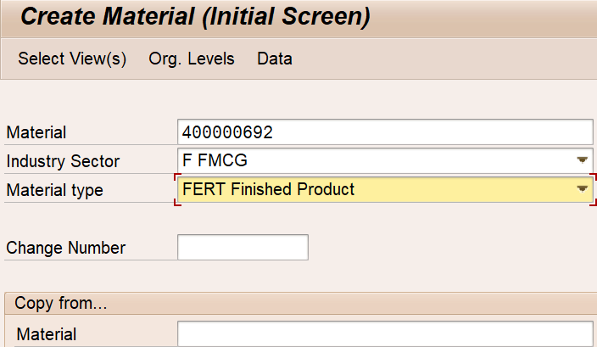

**Put Material Code in Material field, Select relevant Industry Sector & Material Type. Then click Select View(s).**

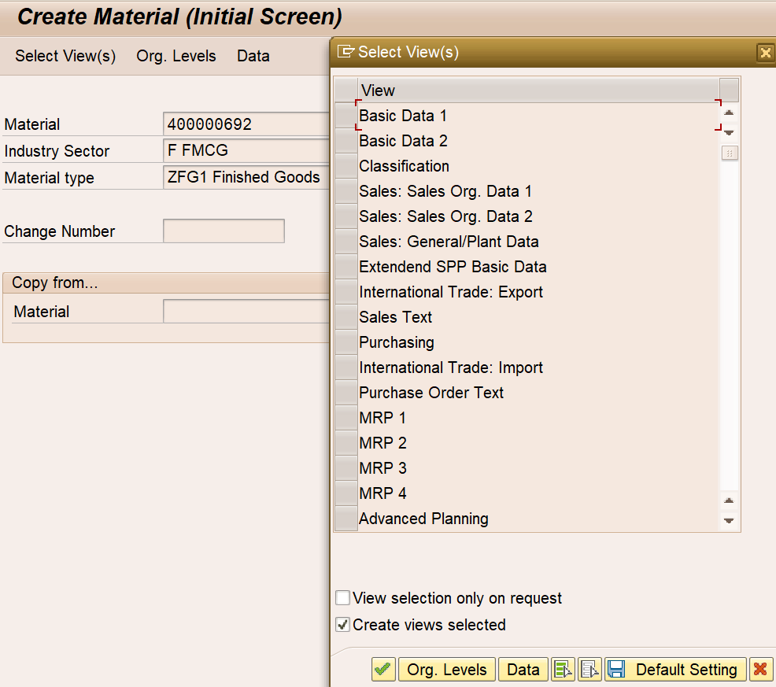

Scroll down the Select View List & select these two views – Warehouse Management 1 & Warehouse Management 2. Then click Green Tick, i.e., Continue (Enter).

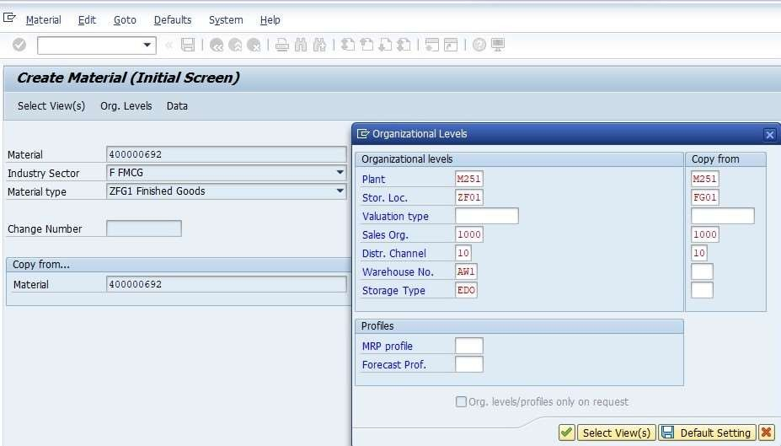

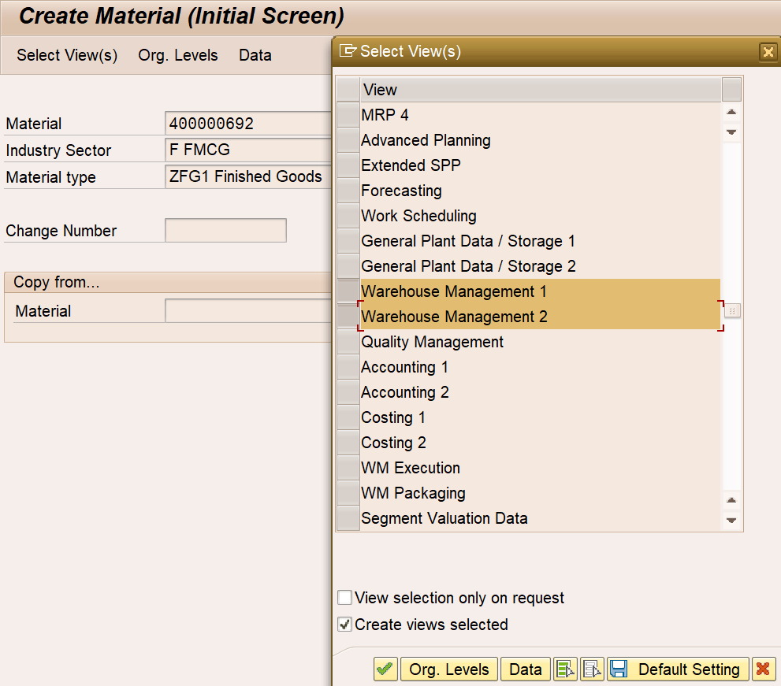

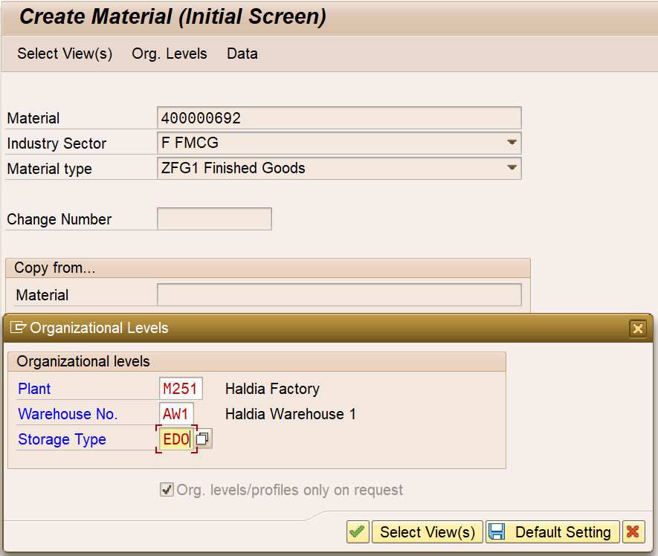

**In Pop-up window, put**

**Plant: M251 (Haldia)**

**Warehouse No.: Desired WH No.**

**Storage Type: EDO (Edible Oil)**

Four Storage Types defined: **EDO**, **RVP** (Rasoi Vanaspati), **SCK** (Soya Chunk) & **SPC** (Spices).

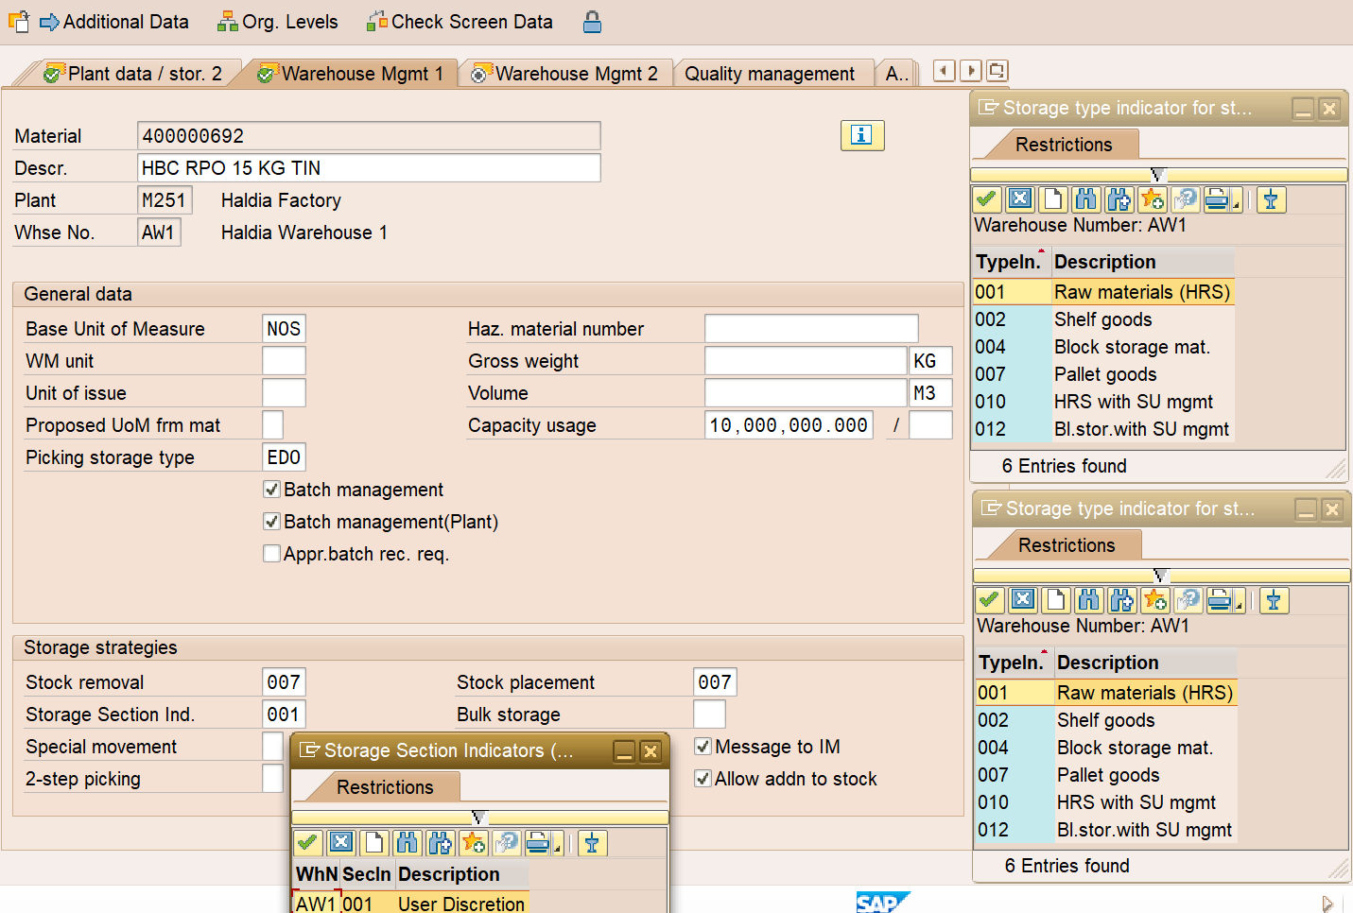

**Select from the drop-down menu of the fields as shown.**

**EDO: Edible Oil**

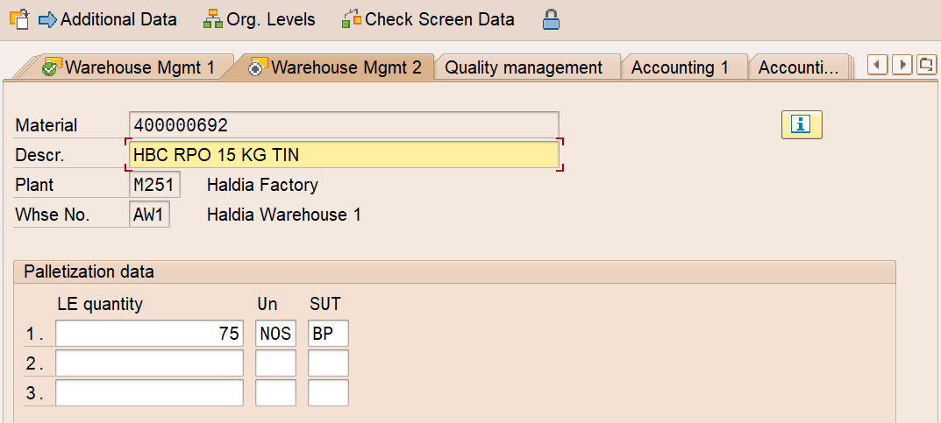

**The LE fields are used to identify how you want this material to put away. LE quantity will indicate how much quantity you are allowed to put on a single pallet. SUT is Storage Unit Type. For EAL, two SUTs defined – BP (Blue Pallet) & WP (White Pallet). You may use two lines – LE qty for manual (BP) & LE qty for robotic (WP) palletization & put away, if reqd.**

**Save**.

Extension of Materials Master is complete.

1. **Bin Master Creation**

Bin Creation Transaction Code: **LS01N** (Manually)

Menu Path: **Logistics → Logistics Execution → Master data → Warehouse → Storage Bin → Create (LS01N) / Change (LS02N) / Display (LS03N)**

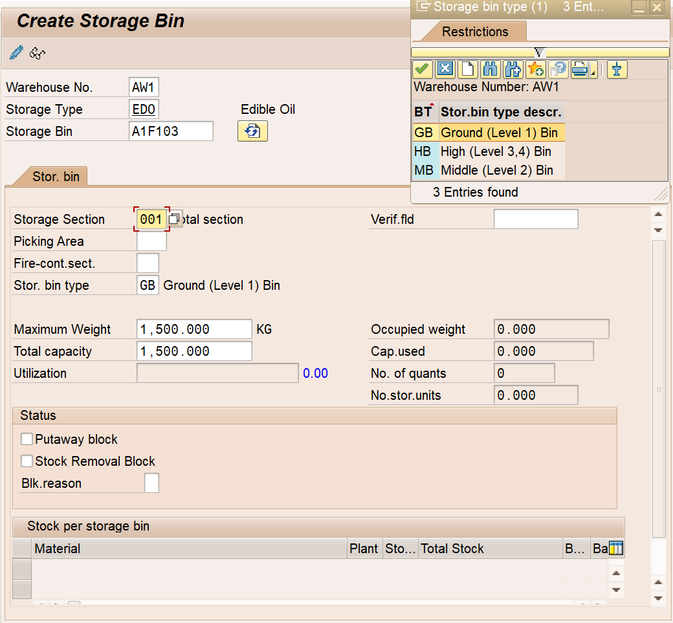

**Put max. bin weight 1500 KG for High Rack Storages**

**If Bin number’s 4th digit – 1: Ground Bin, 2: Middle Bin & 3, 4: High Bin**

**Put WH No., Storage Type & Bin No.**

**Save**.

Note that Bin Number is a 6-digit code. 1st letter represents Plant – A: Haldia, B: Krishnapatnam, C: Kandla & J: Jaipur.

2nd digit represents Warehouse No.

3rd digit represent – F: Finished Goods, S: Staging Bin & R: Repacking Bin.

4th digit represents Level / Floor / Height – 1: Ground Level Bin, 2: Mid-Level Bin & 3 / 4 / 5: High Level Bin.

5th & 6th digit combined represents Row No.

Hence, A1F101 means Haldia Warehouse 1 FG Ground Bin of 1st Row.

A1F201 means Haldia Warehouse 1 FG Mid-Level Bin of 1st Row.

A1F301 means Haldia Warehouse 1 FG High Level Bin of 1st Row.

A1R101 means Haldia Warehouse 1 Repacking Ground Bin of 1st Row.

A1S001 means Haldia Warehouse 1 Staging Ground Bin.

Storage Section is always 001 which means Total Section.

**Production Process**

In EAL, the Production follows the steps stated below.

**Integrated Business Planning (IBP) Excel** file comes to Plant Shop Floor Manager → Run in SAP → Execute MD04 (Stock / Requirement List) → See *STCK Line Item against a specific SKU → Double Click → Create Process Order (COR1 is triggered in the background) → Release → Save.

Based on the created Process Order, the production process is carried out in specific Line(s) of Operation.

M/s. Specgraph has provided & installed Thermal Printer in Edible Oil Pouch Line 4 (Warehouse 1), Edible Oil Tin Line 4 (Warehouse 2) & Rasoi Vanaspati Line 1 (Warehouse 3) to create & print QR codes for the Cartons, Tins & Jars.

QR Code contains combination of five parameters, viz., Line of Operation, Shift, Batch Code, SKU Code (Material Code) & Carton / Tin / Jar Serial Number.

The screenshots of printer are given below. Printer panel –

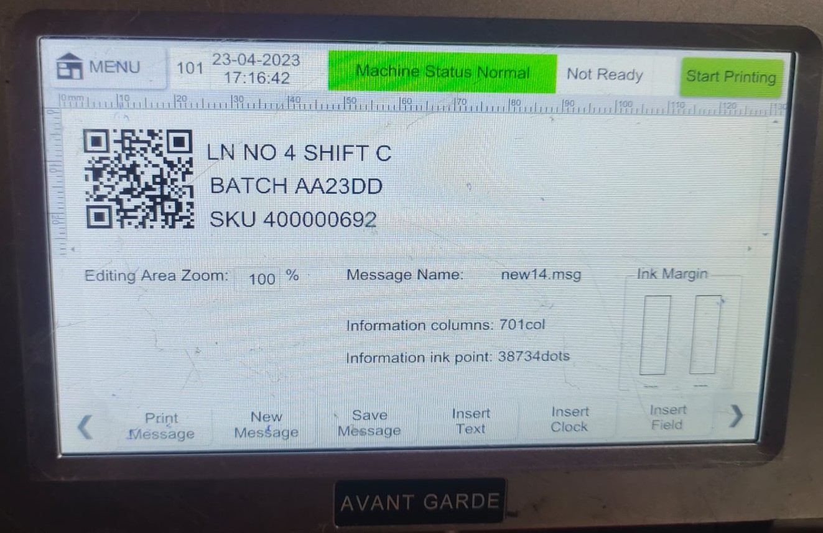

Go to Menu to setup the parameters to create the QR code. The desired texts are to be written with comma-separated values inside the QR Code. **If the texts are not written with the desired separation by comma, the QR Code can’t be generated**.

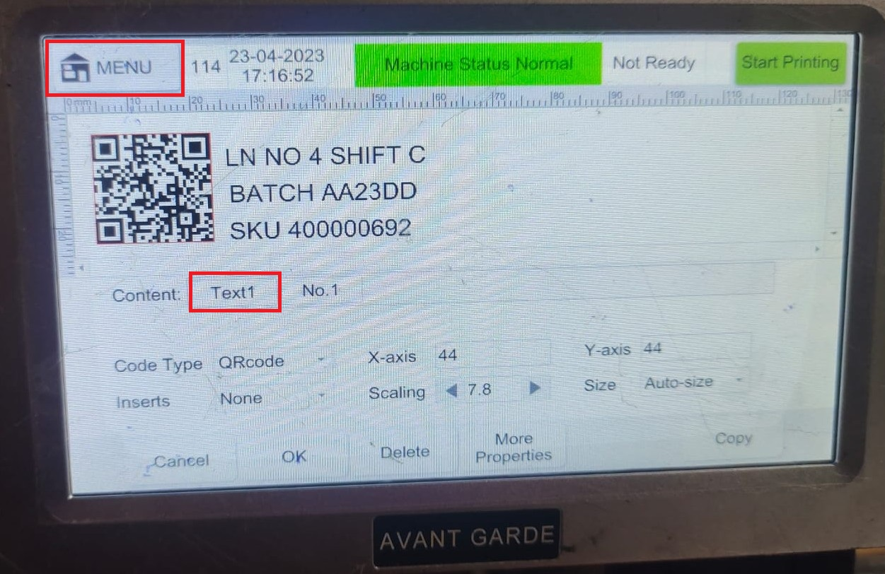

In the tab Text1, information are to be fed in the printer display (Line, Shift, Batch, SKU Code) –

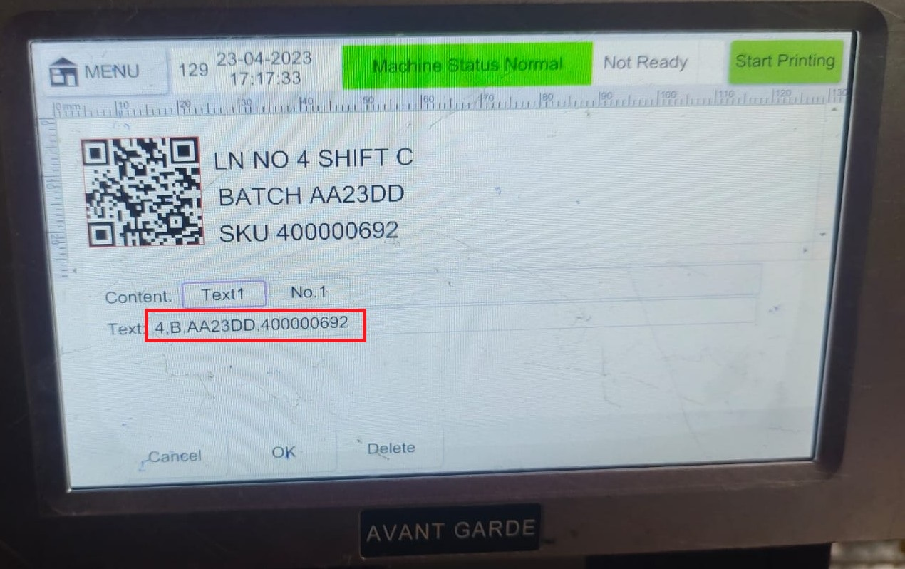

Click “Start Printing” at the Top RHS Corner.

Scanner 1 is installed at the exit point of the boxed area where carton sealing & printing is happening. Scanner 1 is scanning the printed QR code with flashing Red Light of the scanner. If scanner is able to scan / read the printed QR code successfully, the Green Indicator flashes with a sound.





One Android App **Emami WM** (for Android 12 & above) is installed in the Industrial tab (OEM: Newland) which captures the palletization i.e., QR Codes of scanned Cartons / Tins / Jars.

**Tab Operations:**

**Step 1:** Open the Android App

**Step 2:** Login with correct credential

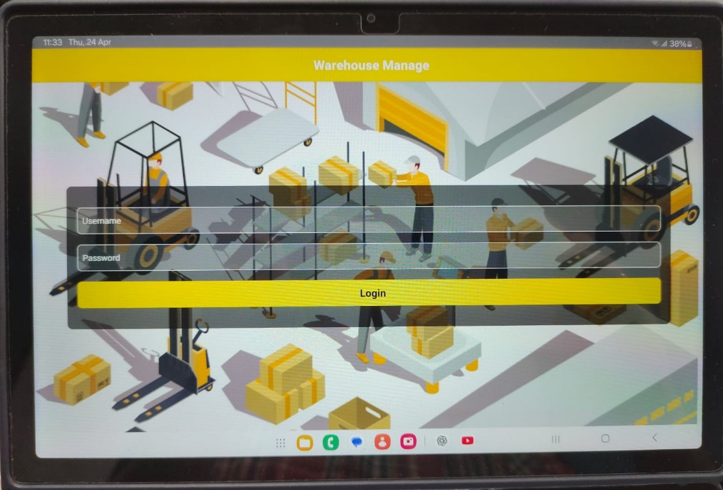

**Step 3:** Click Production Block

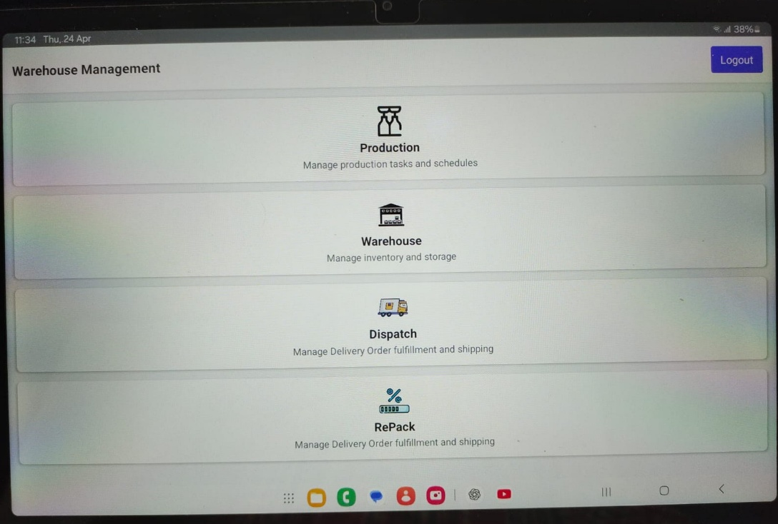

**Step 4:** Click Manual Palletization Block

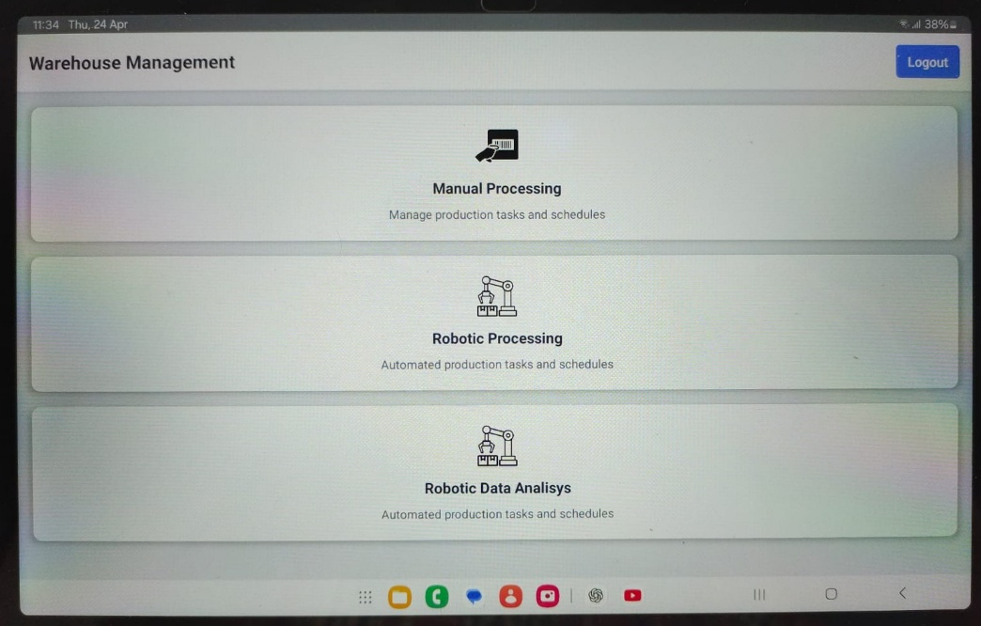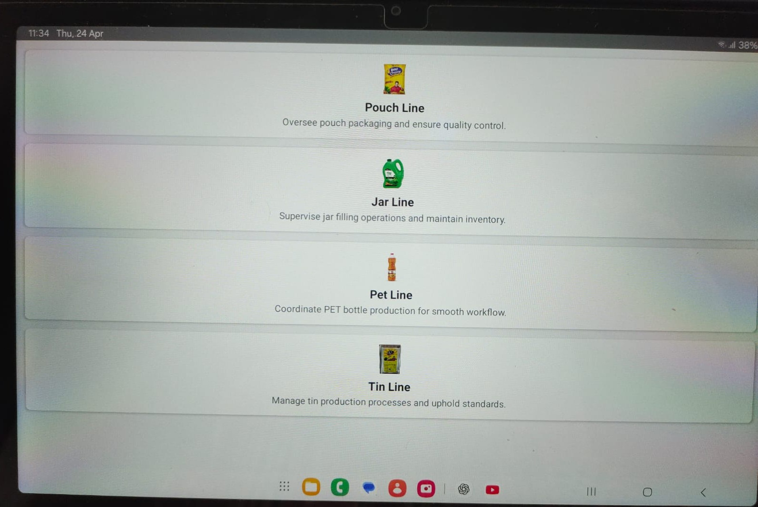

**Step 5:** Click the correct Line of Operation (Pouch / Jar / PET / Tin)

**Step 6:** Put the correct Process Order No. & click “Get Info”.

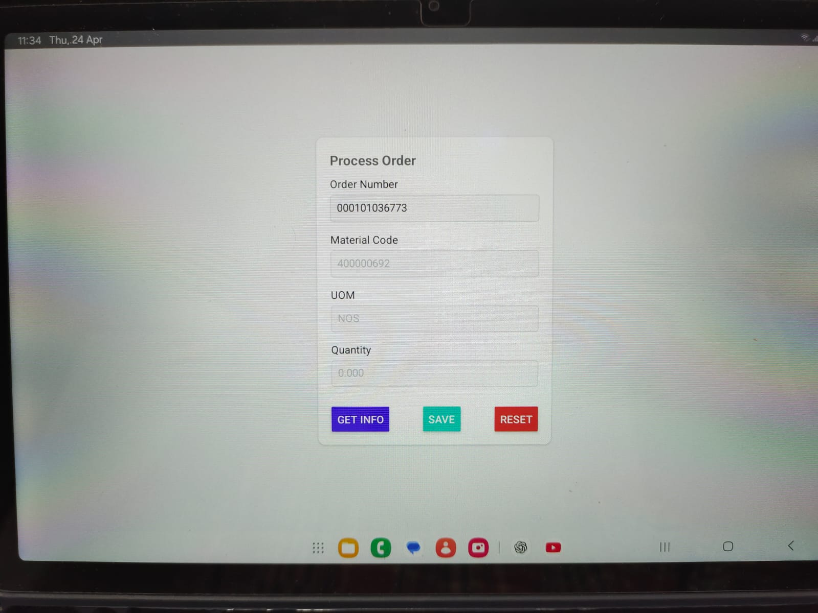

**Step 7:** When Material / SKU code & Quantity are shown in the screen, click “Save”. The page would automatically change to the scanning display screen.

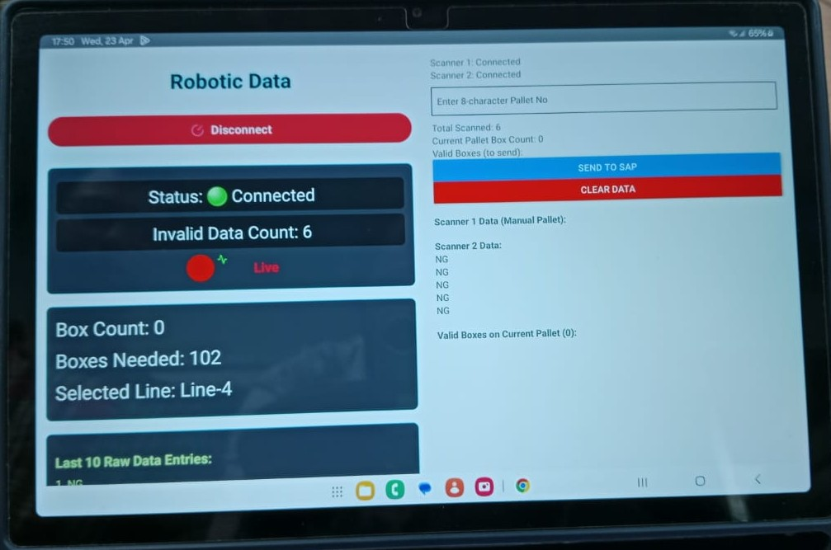

**Step 8:** For manual palletization, touch the blank field of Pallet ID, scan the Pallet Bar Code with Handheld scanner. The Pallet ID would get reflected in this field. Pallet ID has 8 characters / digits.

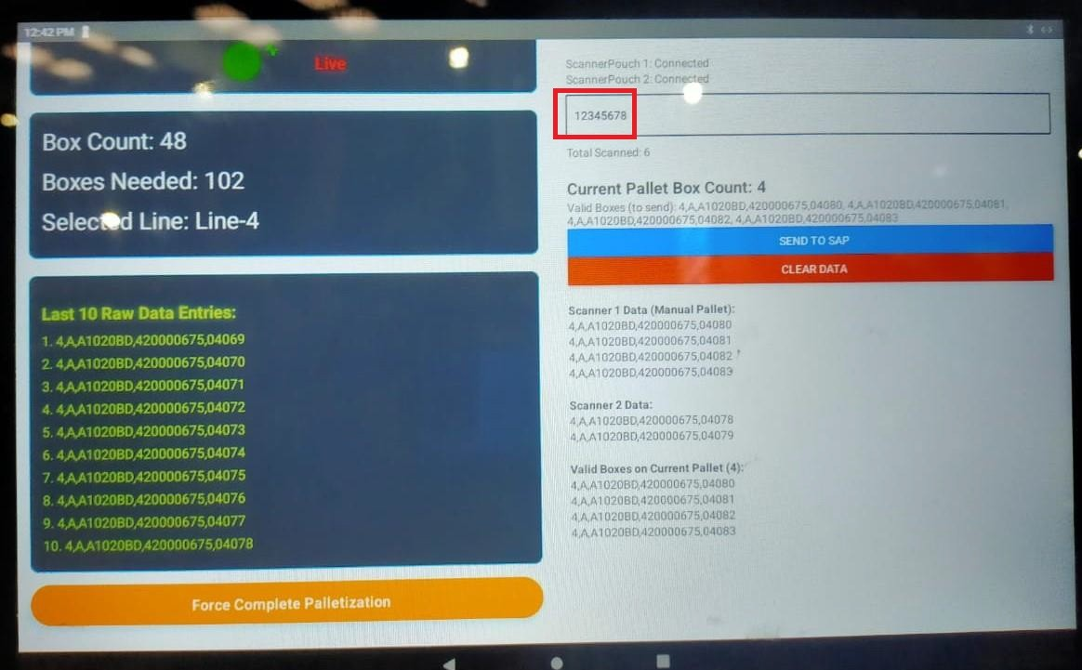

**Step 9:** After completion of manual palletization, click “**SEND TO SAP**” (Blue Box).

For Bin placement (Putaway), Handheld Terminal (HHT) is used. In HHT, the same Android App is installed where user needs to select the “Warehouse” block. The next screen is –

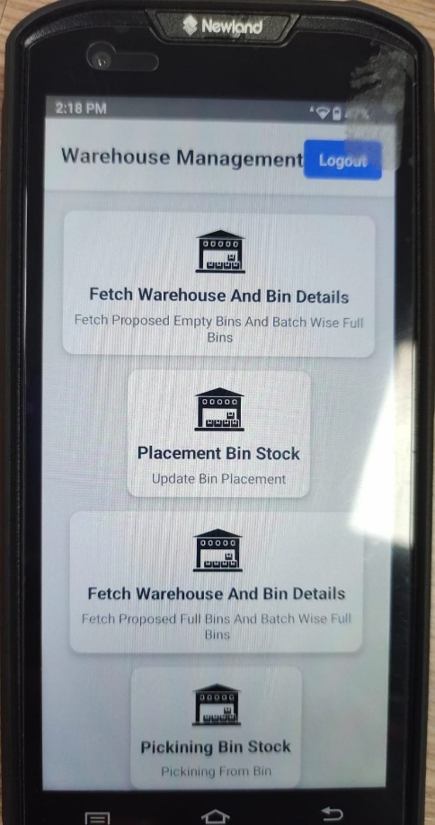

Then user needs to select Placement Bin Stock. In the next screen, Pallet ID (Barcode) & Bin No. QR Code are to be scanned. Then click “Send to SAP”.

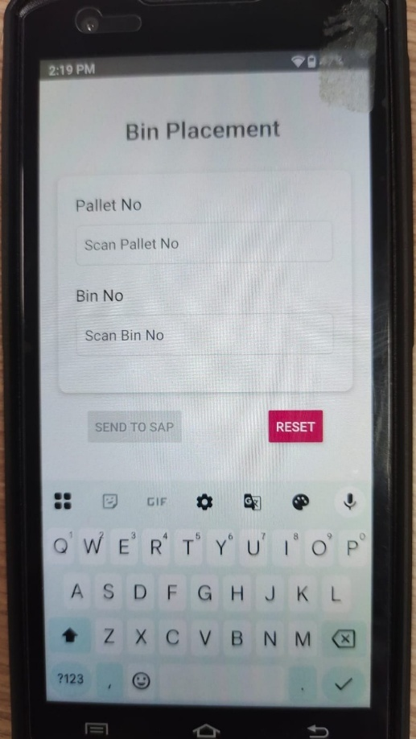

The manual pallet is placed in that specific Bin.

Robotic Palletization Data is coming from Scanner to a Server running a Node.js Application (<http://10.255.7.60:3000/dashboard/connection-monitor>).

Home Page → Production Dashboard → Click Desired Scanner for Scanned Data of Production → Select “Line Item” tab among Summary, Line Items & Statistics tab

Production Dashboard Snap –

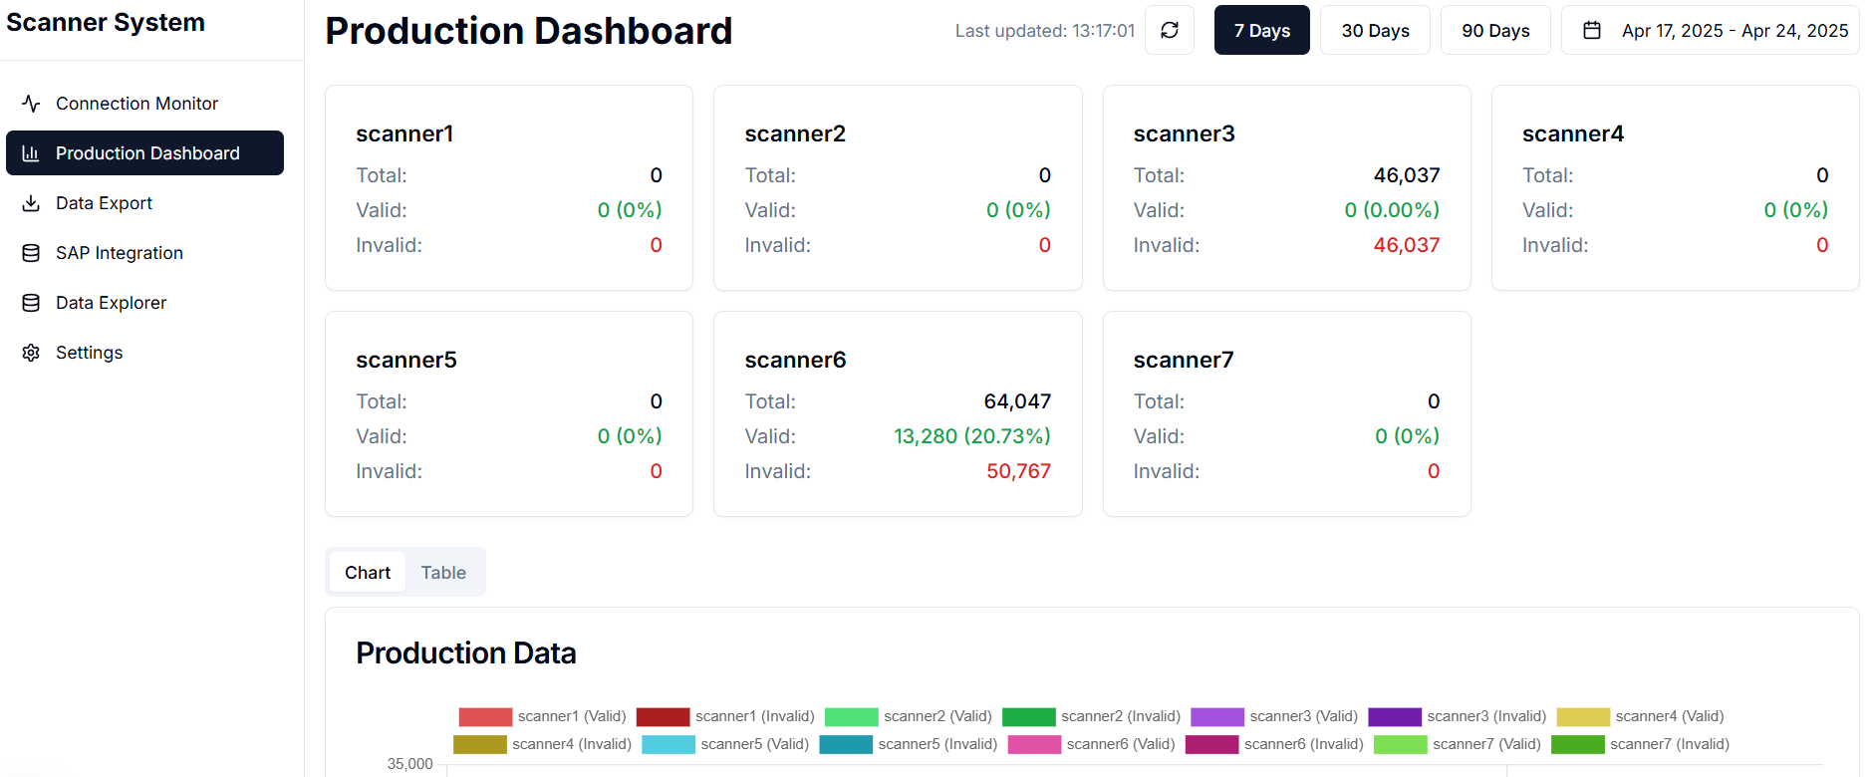

After clicking any scanner box (here Scanner 6 or Tin Line 3rd Scanner) –

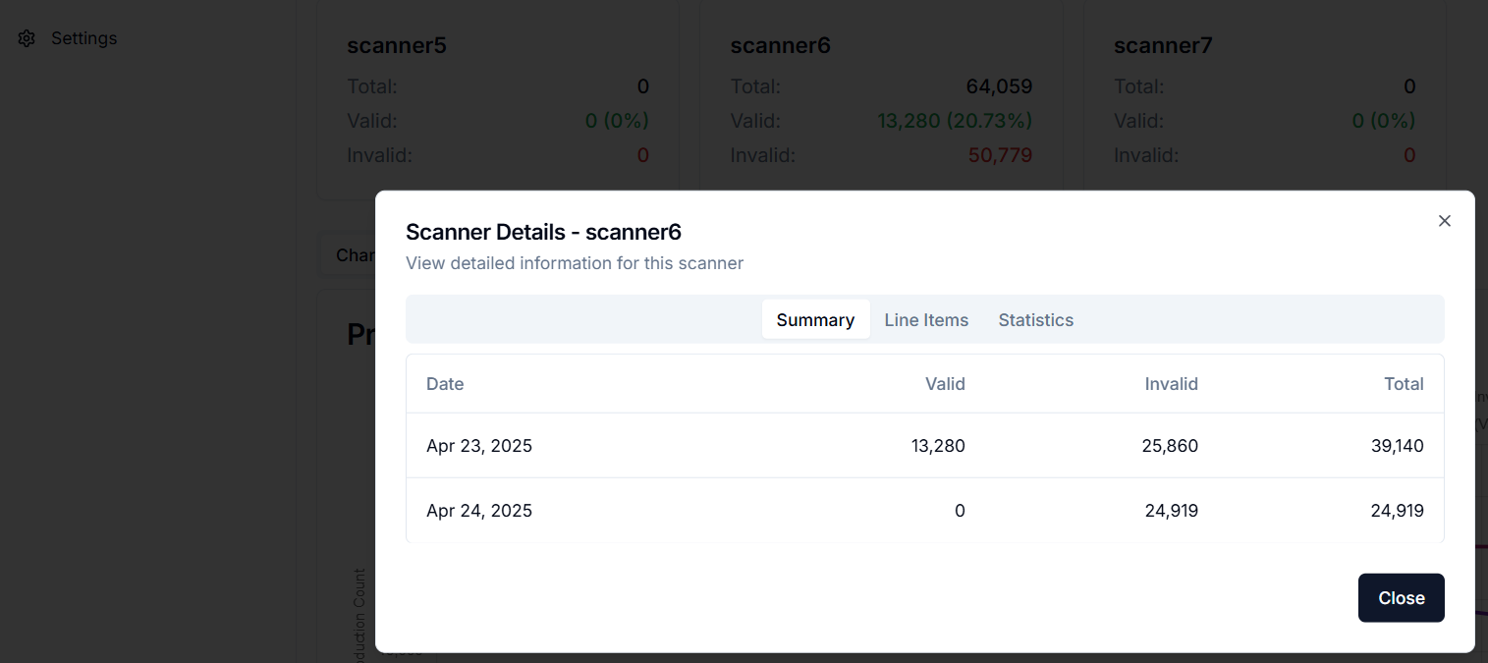

After clicking Line Items Tab, the screen looks like below. The data can be exported to Excel.

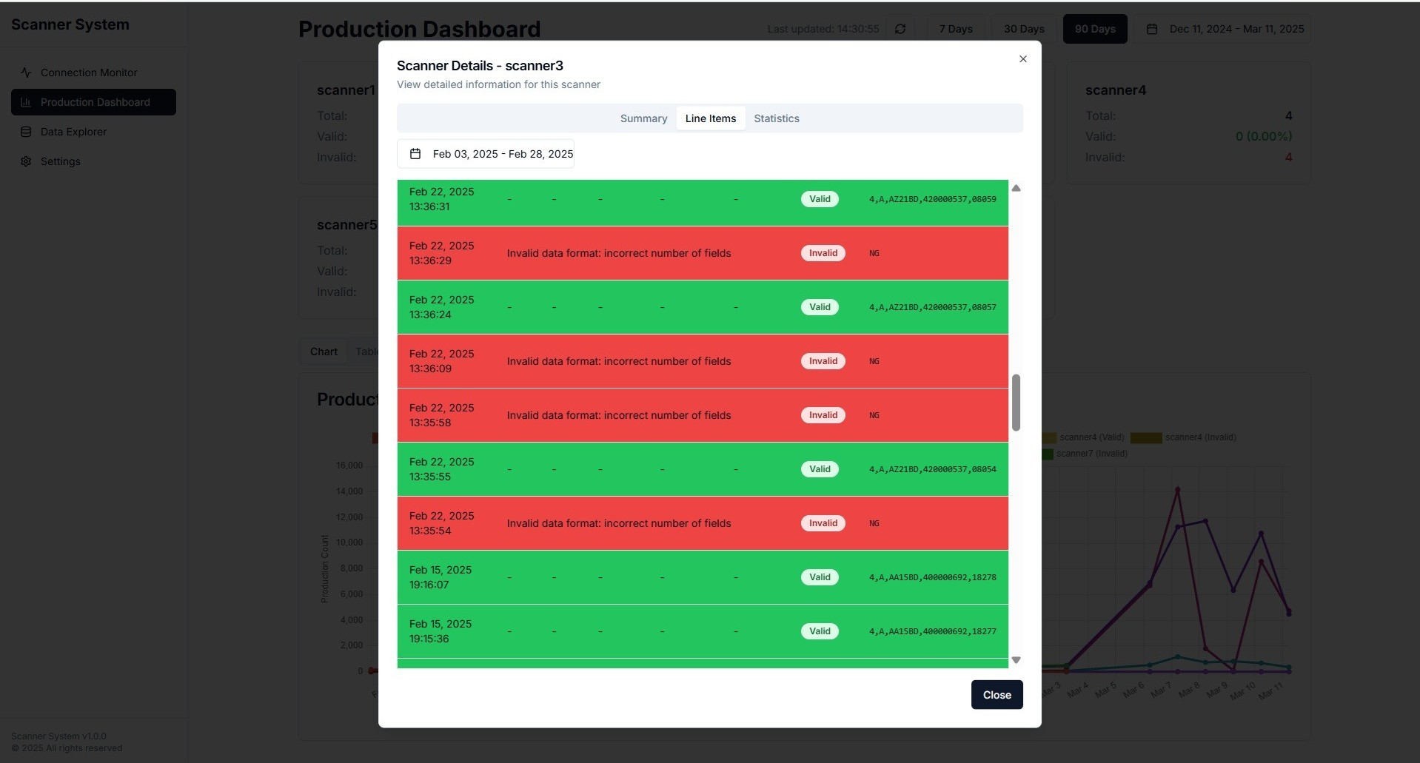

In SAP, there are few custom tables (Z tables) maintained for the Production process.

1. ZWM_GETBIN: Mapping Plant, Storage Location, Storage Unit Type, WH & Material Group
2. ZPP_UOMC: Manual / Robotic Palletization UoM conversion (Box Quantity to Item Quantity)
3. ZPP_PALLET: Manual /Robotic Palletization (Process Order Confirmation)
4. ZPP_CARTON_ITEM: Carton Serial Number (w.r.t. a particular Pallet)
5. ZPP_TOLERANCE (created by EAL): Tolerance limit

Robotic or Manual Palletization data (Pallet details) are stored in ZPP_PALLET table. The front-end of this table is made available through T-Code ZPP_PRO_ORD.

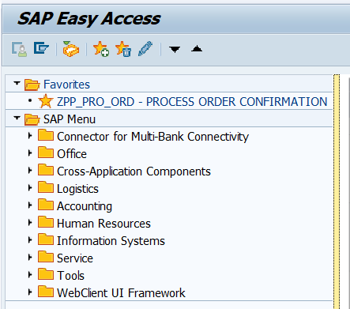

Executing ZPP_PRO_ORD, this screen comes –

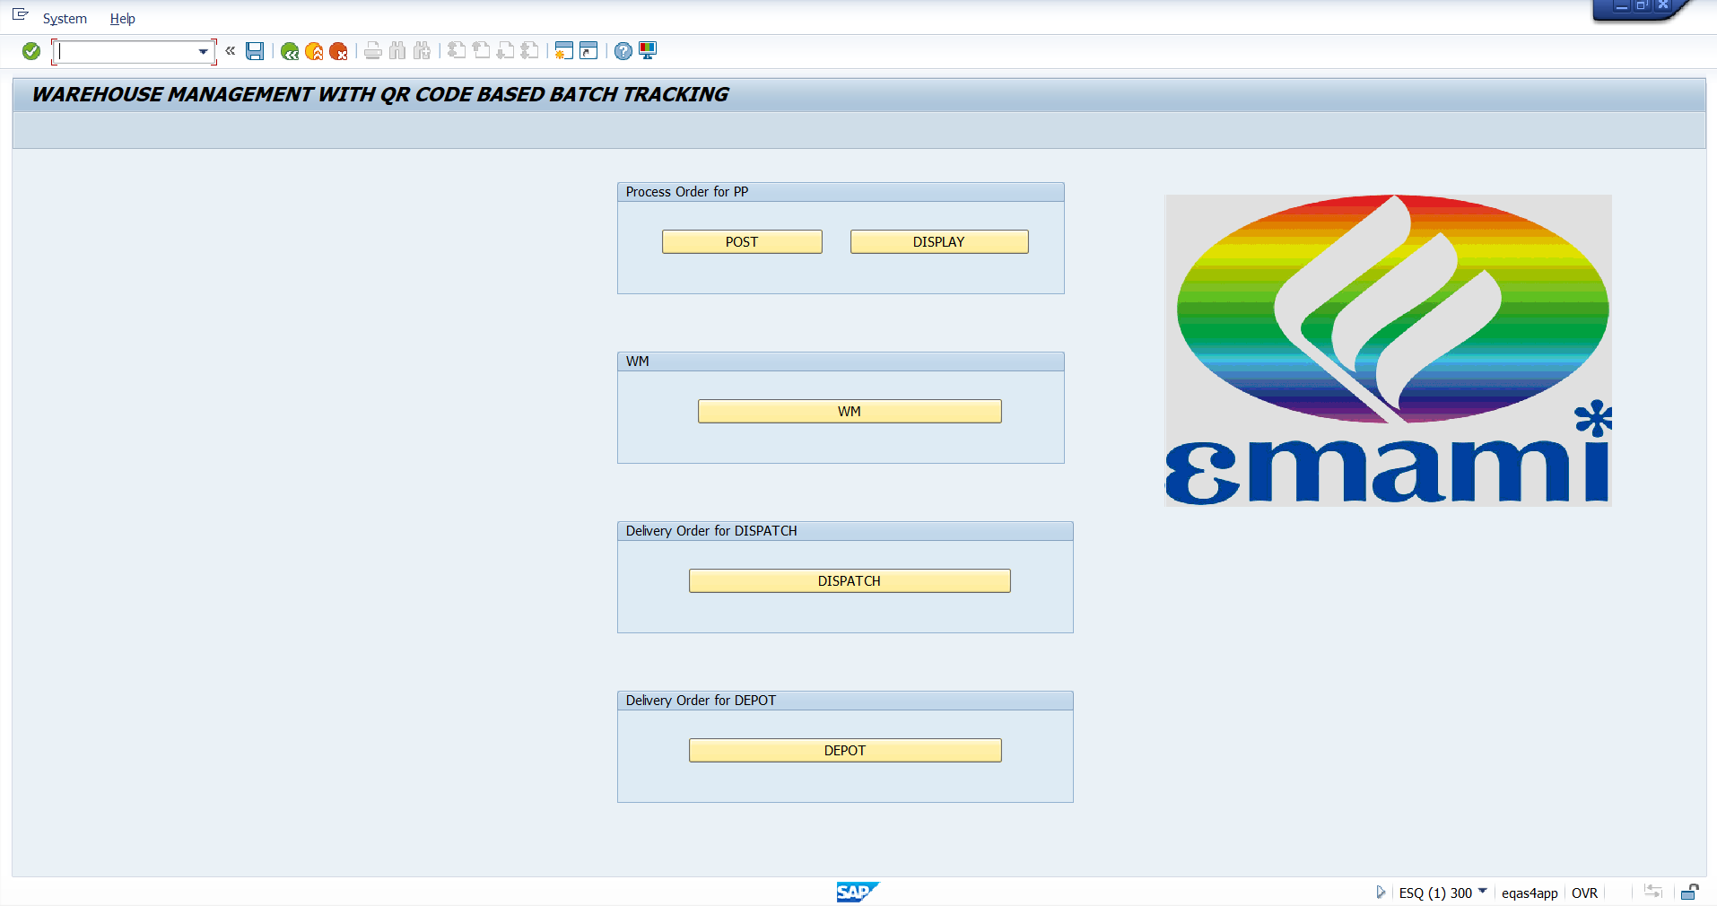

For posting Production Confirmation (i.e., Process order Confirmation), click “Post”. There is a pop-up user selection screen like –

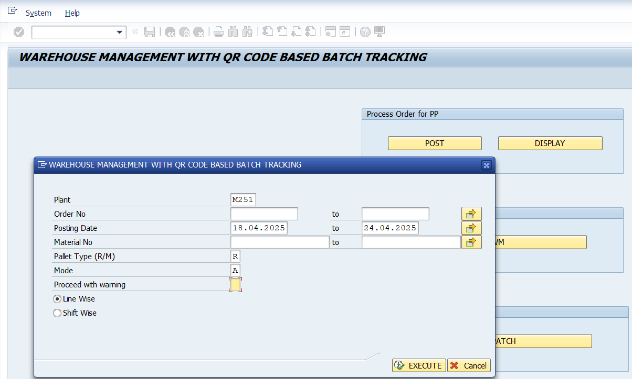

Plant & Posting Date fields are mandatory. For viewing Robotic Palletization data, select Pallet Type (R/M) as “R” and for Manual, it is “M”.

After executing, the next screen looks like –

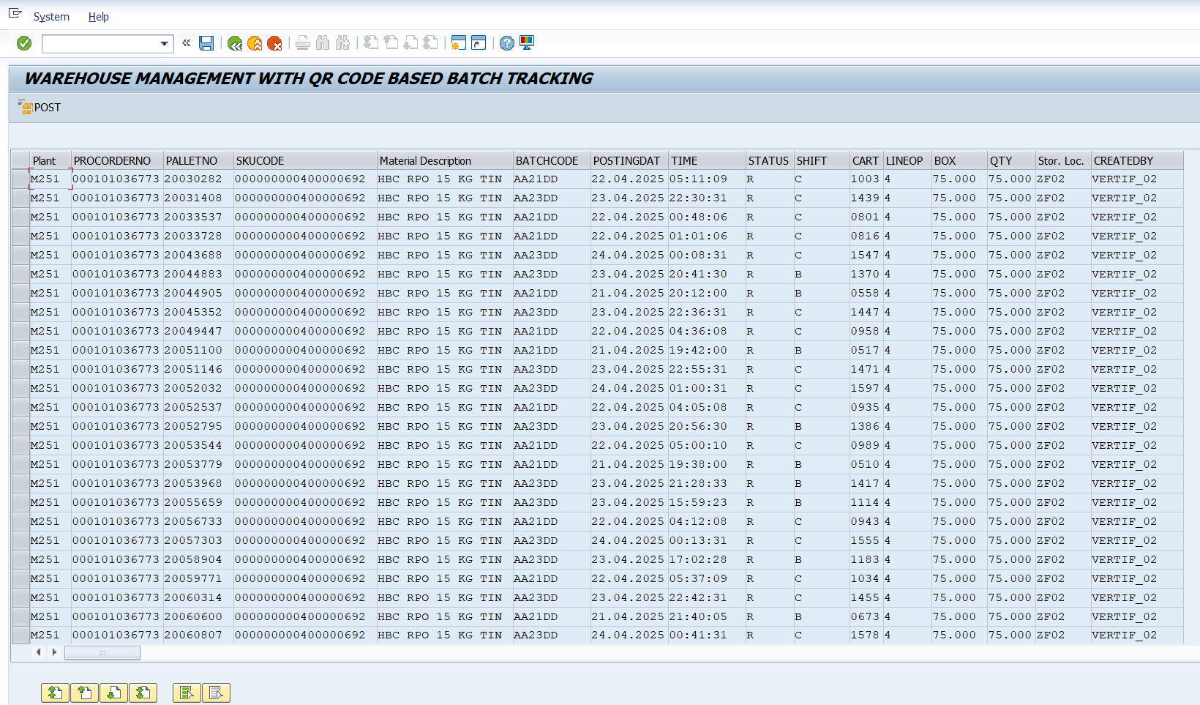

Select the desired Pallet rows of a single day (because one day corresponds to one Batch Code) and click “Post” at the top LHS. It calls the standard SAP T-code COR6 (Process order Confirmation).

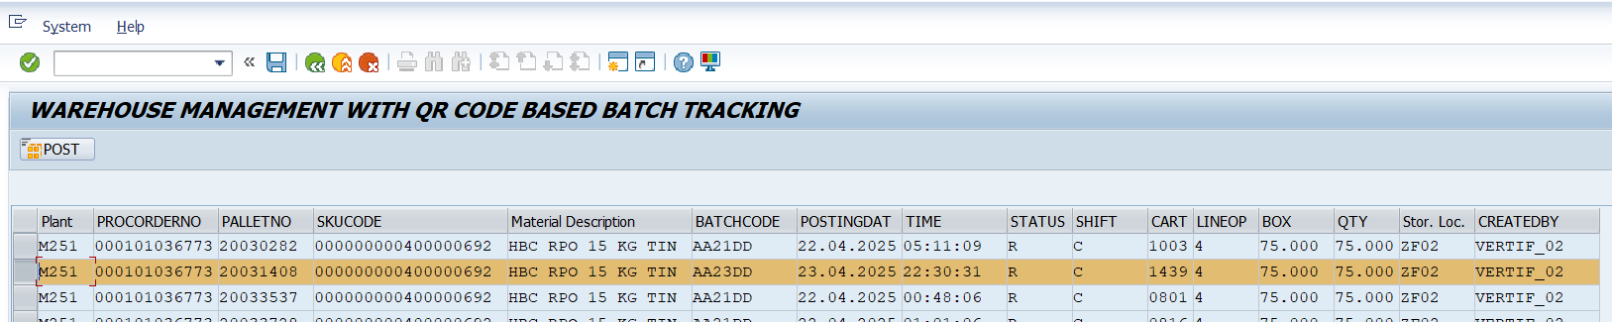

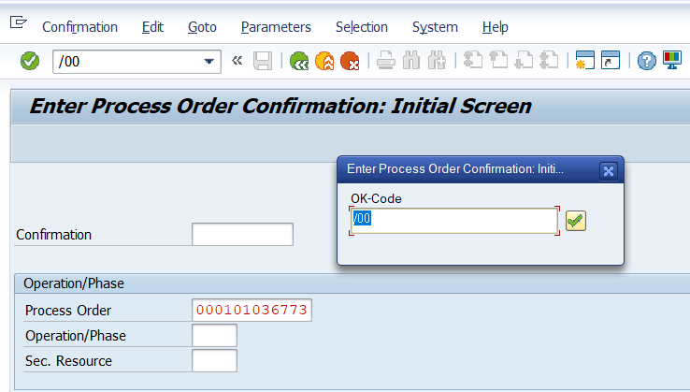

Click enter or click “Green Tick” a couple of times. After every such enter or click, it does the calculation or desired steps of COR6 –

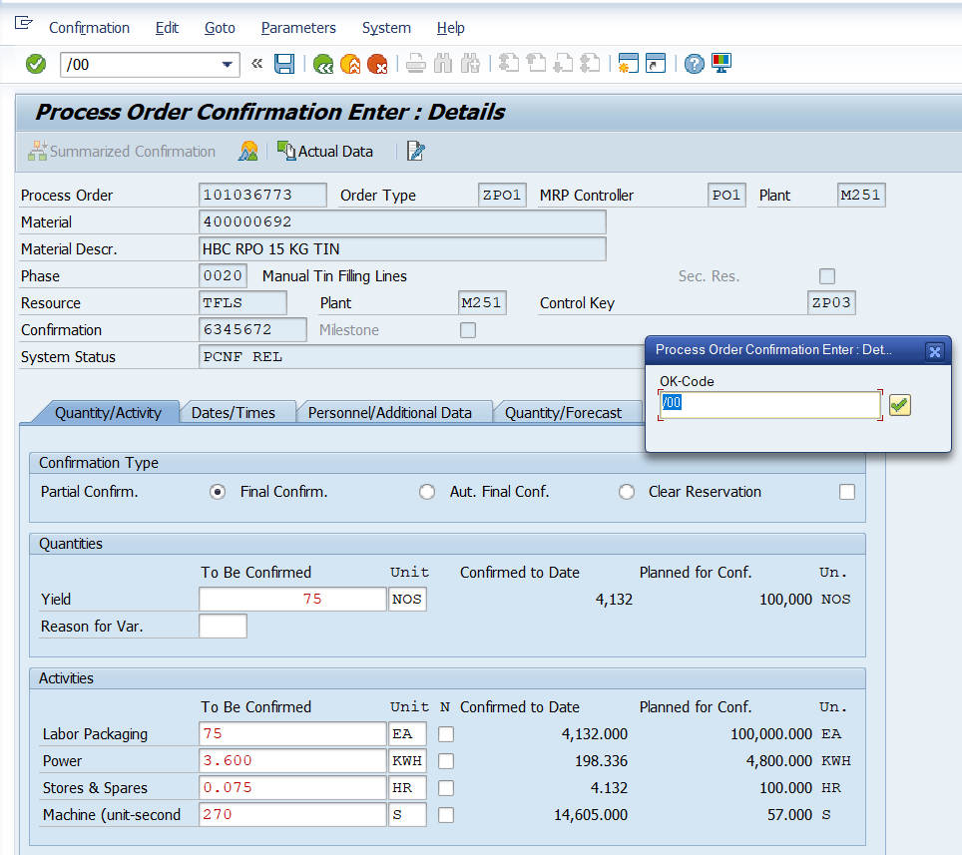

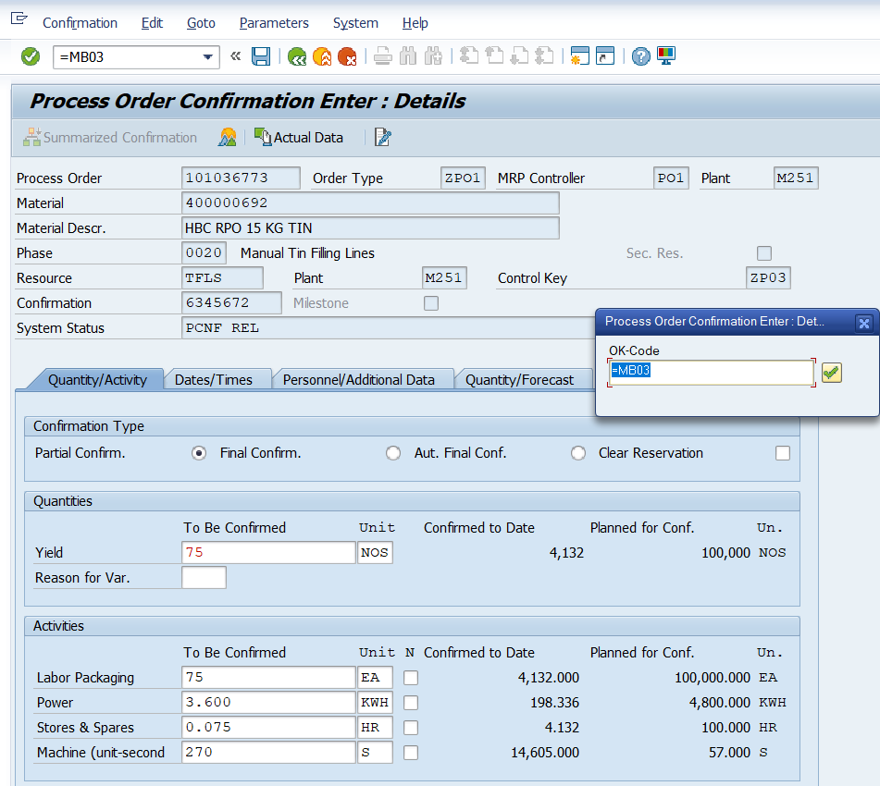

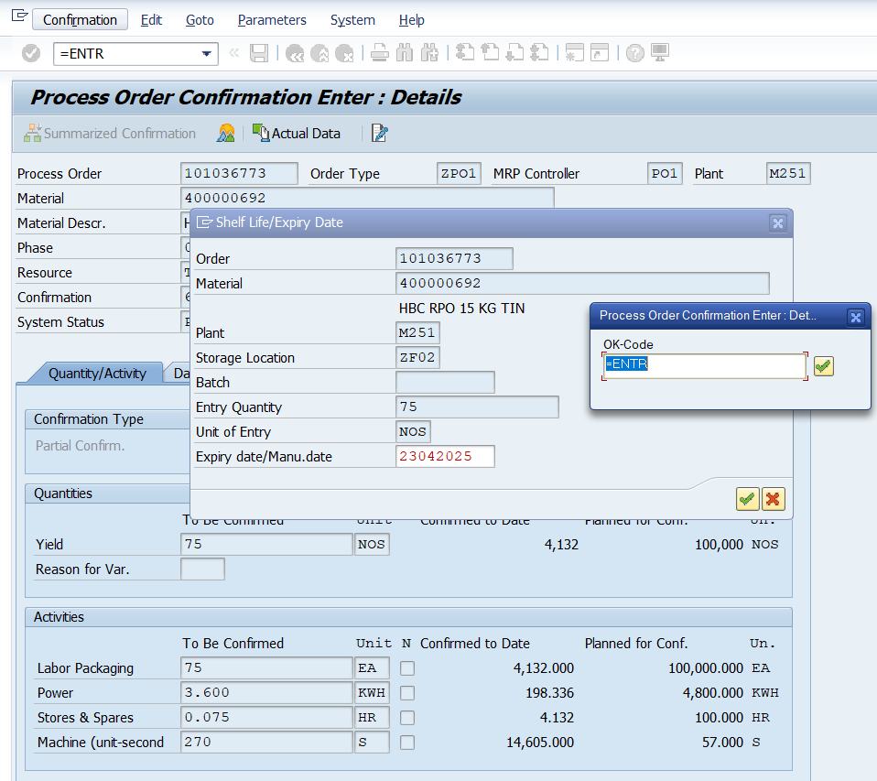

After entering, the next screen looks like –

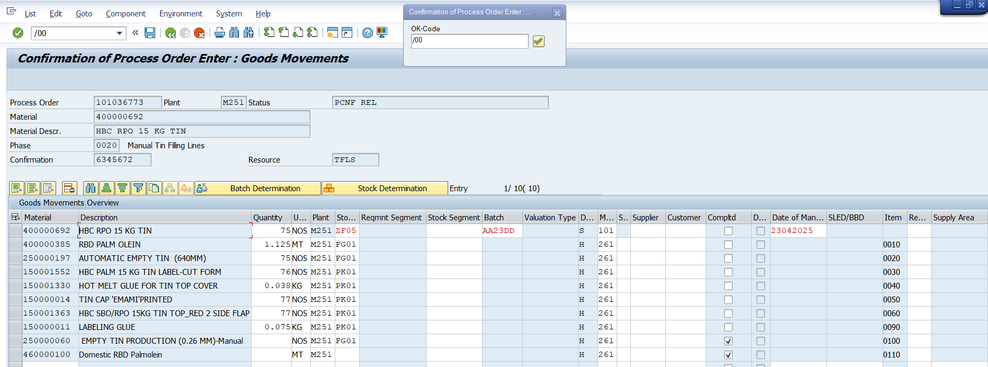

In this screen, there are different validations are running at the background to check –

1. If the BoM materials’ quantities are within the tolerance limit as per ZPP_TOLERANCE.
2. If SLoc of any BoM material is present or blank.
3. If Quantity of any BoM is zero or blank
4. If quantity is blank, it will also check if the concerned BoM material is alternative BoM material
5. If the Stock in the concerned SLoc is zero
6. If the BoM materials are of Material Type ZSF1 (Semi-Finished Goods) & Material Group 0308 (Ply) combination and of material type ZRM1 (Raw Materials) [such material numbers are starting with 10 or 15 or 25], then their Batch Code(s) must be put.

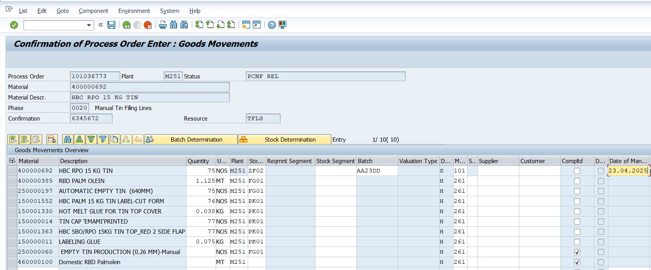

Enter & Save. The Pallet Data posted can be seen in ZPP_PRO_ORD screen from clicking “Display”.

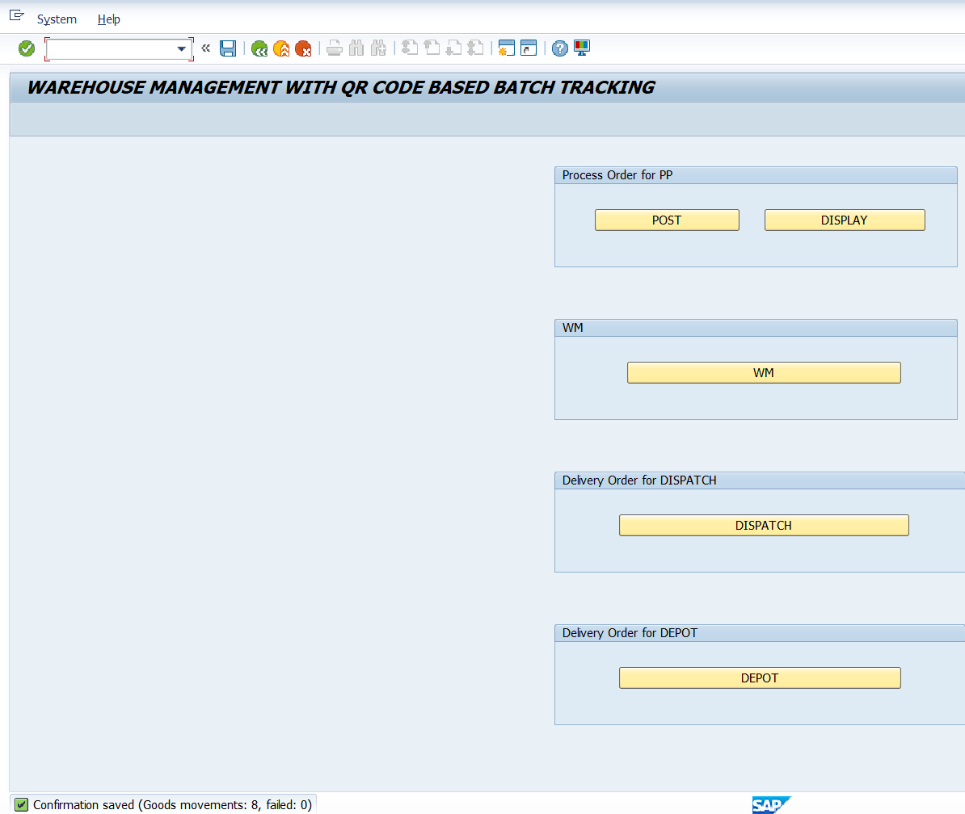

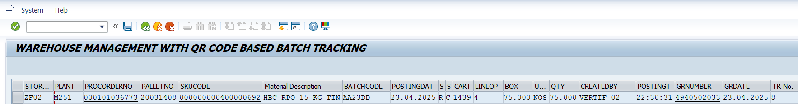

This pallet now goes for Quality Release (T-Code: QA32)

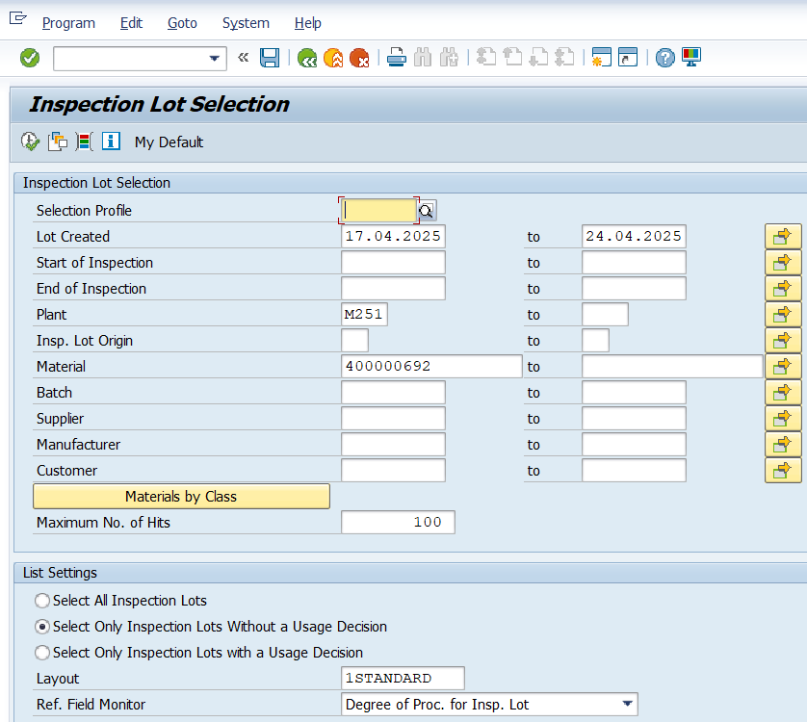

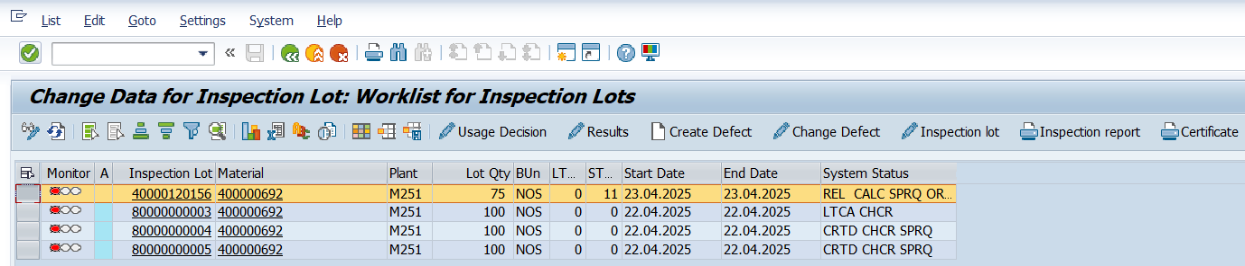

Select the desired Inspection Lot & Click “Results” for Results Recording (RR) –

User would put the desired result & save.

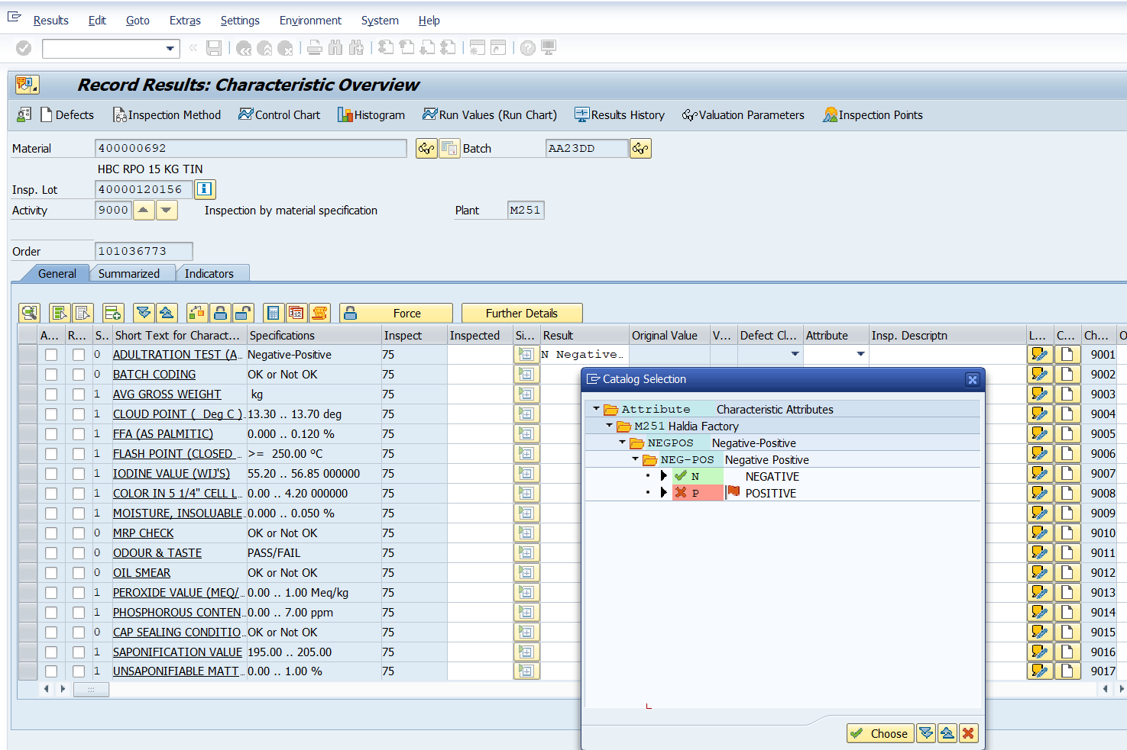

After saving, it goes back to initial screen where system status has changed to Results Recording done (RREC) -

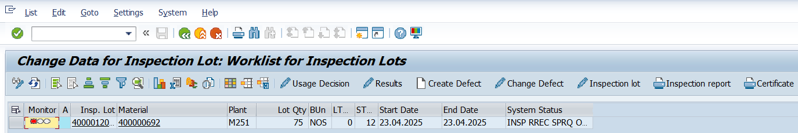

Select the line & click “Usage Decision” button. In the next screen, while putting UD Code, there is a pop-up window –

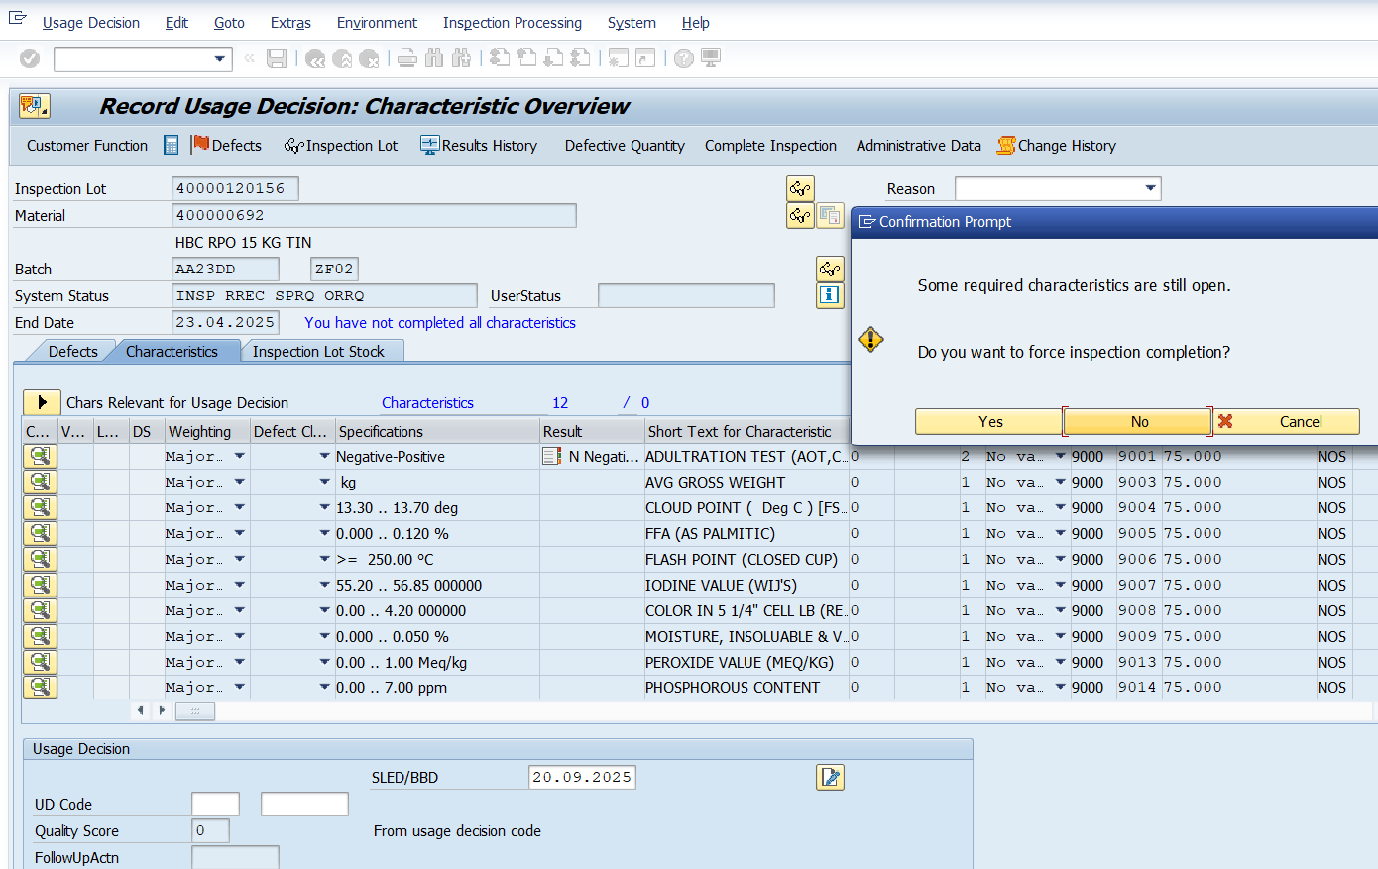

Click Yes. Put UD Code (here for Accept, A)

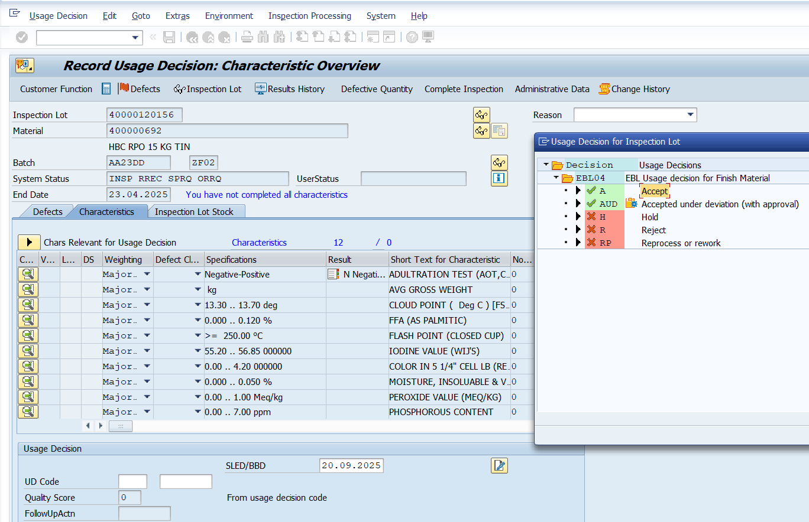

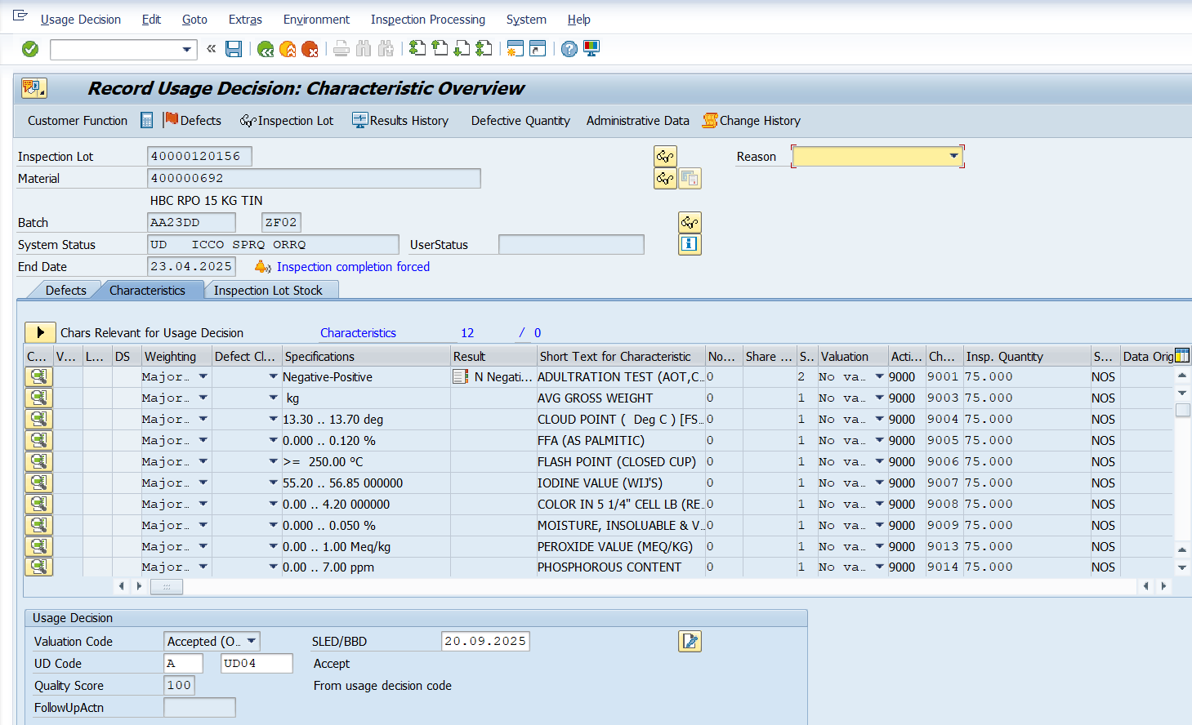

Click inspection Lot Stock tab, put the desired quantity for “To Unrestricted Use” field –

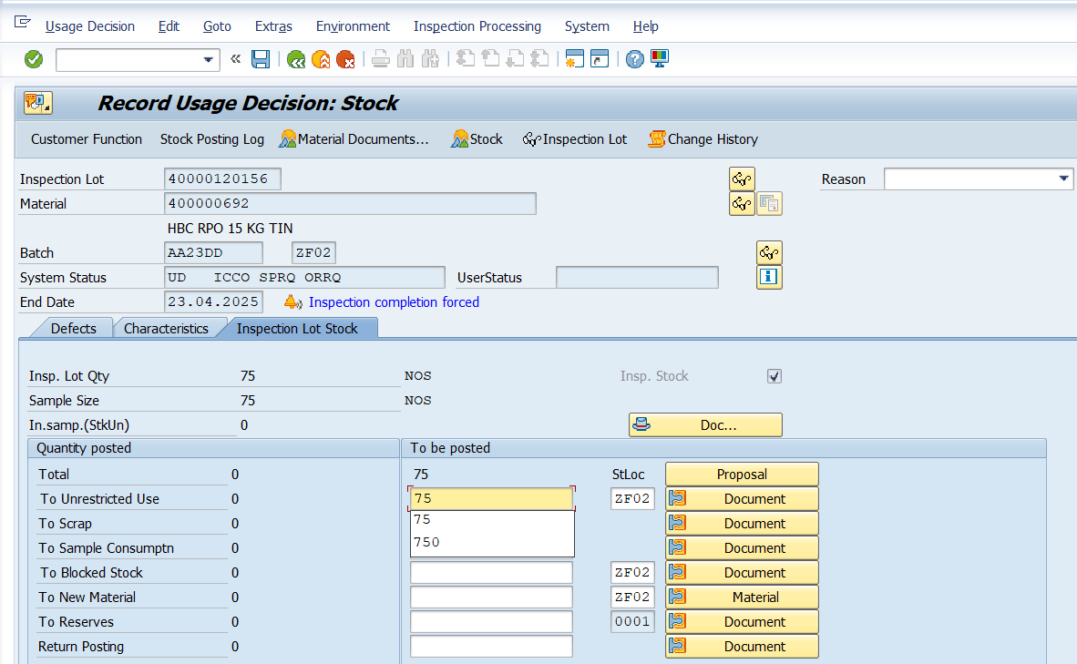

Save. System status is changed to UD done (UD ICCO SPCO ORRQ)

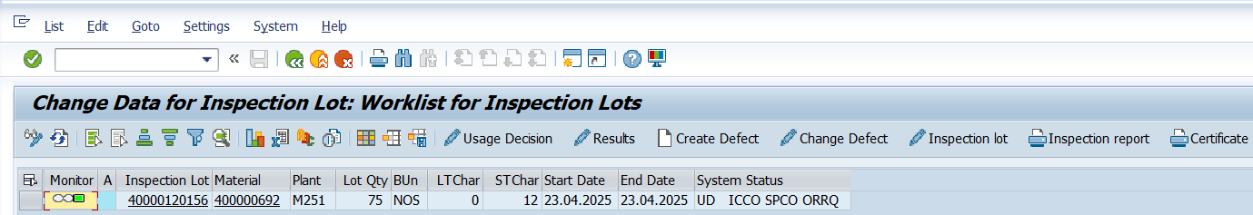

After this, there is a background program of Bin placement which is LT04. It creates a Transfer Order (TO) against which placement of a certain quantity of a certain batch of a material to a particular Bin happens.

Stock update can be seen through MMBE or LS24.

MMBE View –

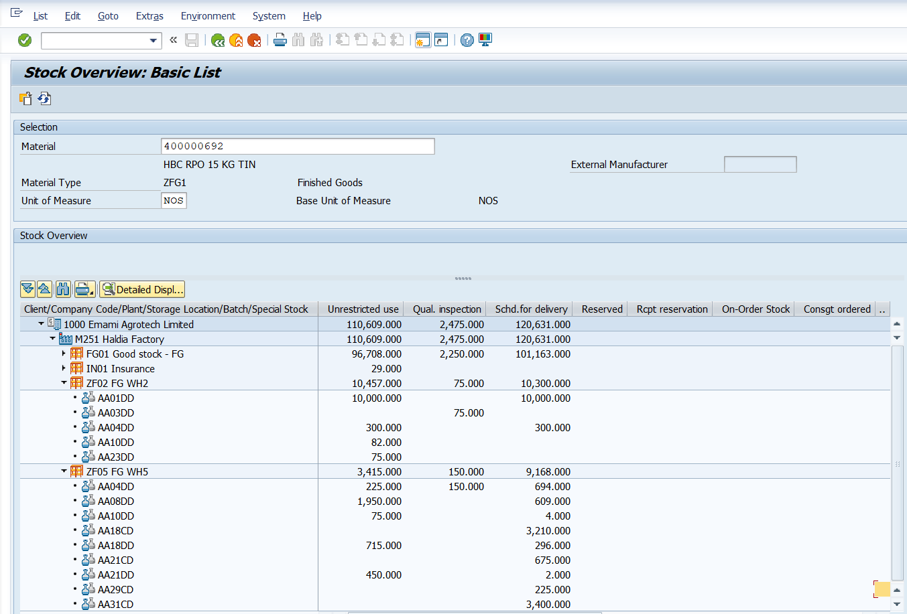

Stock per material Bin related (LS24) View –

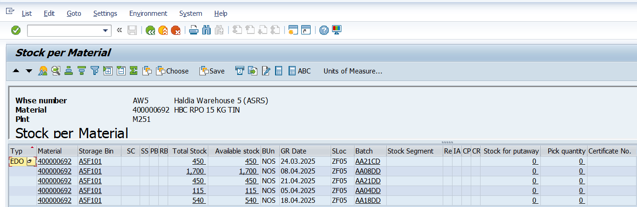

**Dispatch Process**

There are 3 types of Dispatch in EAL – Normal Dispatch, Modern Trade (HORECA) & Rake Dispatch. Accordingly, there are three blocks under the Dispatch module in the Android App.

Dispatch is carried out from different Docks following certain loading sequence of material types (as defined in Product hierarchy). Hence, few custom tables have been created –

1. ZWH_BAY_MASTER: Bay Master Data
2. ZWM_PRD_SEQUENCE: Loading Sequence of Materials w.r.t. Product Hierarchy
3. ZWM_SEQUENCE: Dispatch Loading Sequence w.r.t. materials
4. ZWH_DISPATCH: Warehouse Dispatch Data

Bay Master is maintained in SAP & it is duly reflected in Android App. After login, select Dispatch Block, then select Dock Status block.

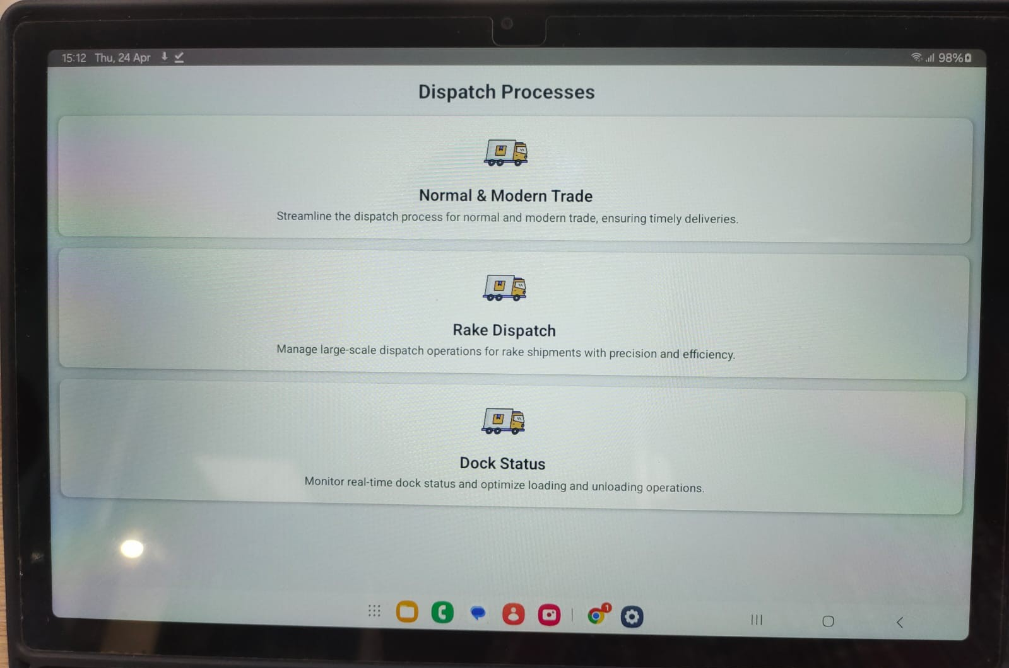

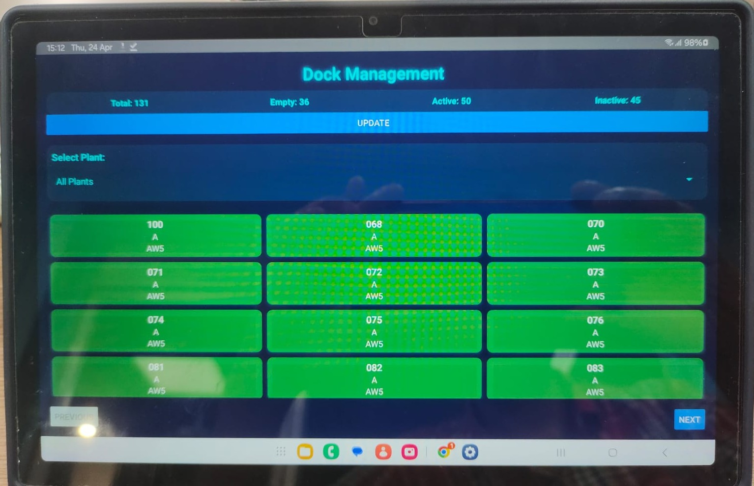

Plant can be selected from “Select Plant” Drop Down menu –

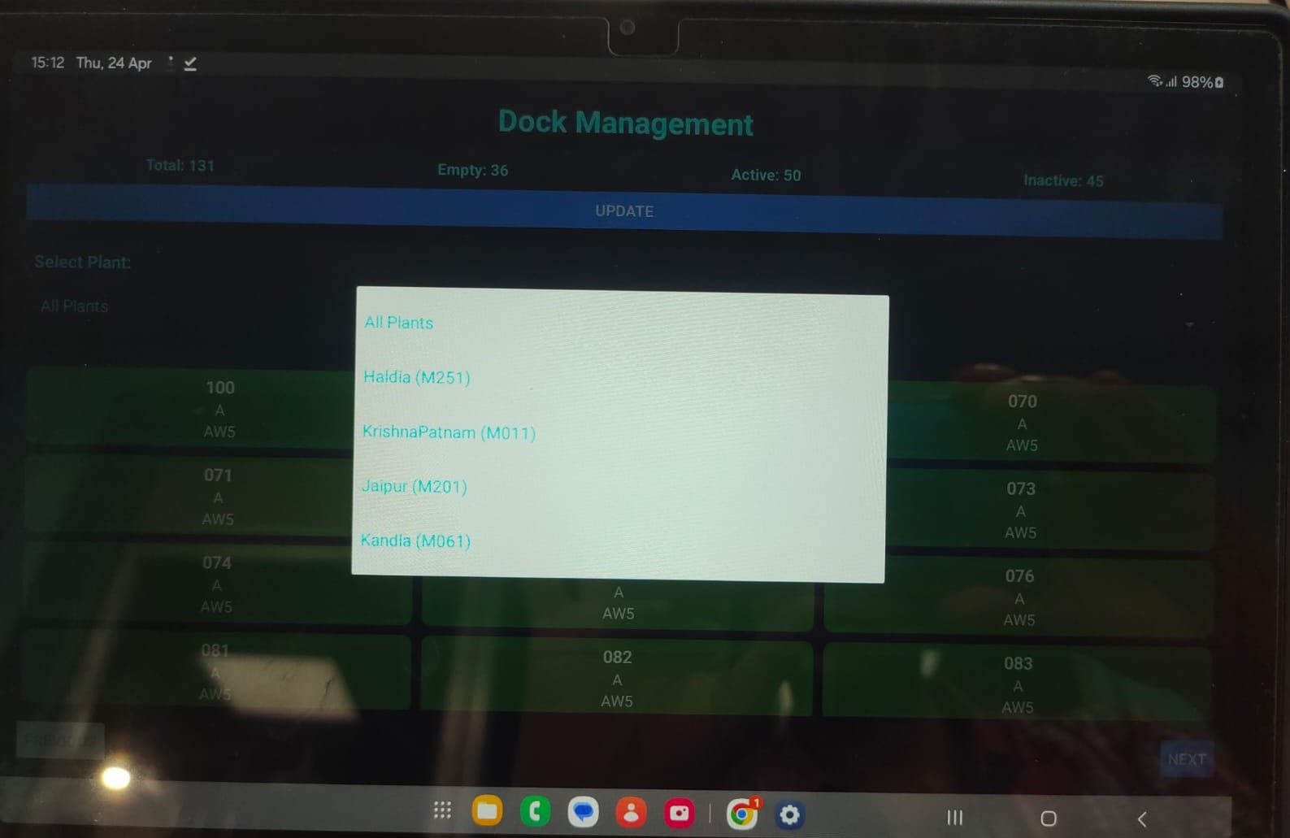

Dock / bay status can be updated in Android app. If truck is docked in a bay, it is “Active”, when no truck is allocated to a bay, it is “Empty”.

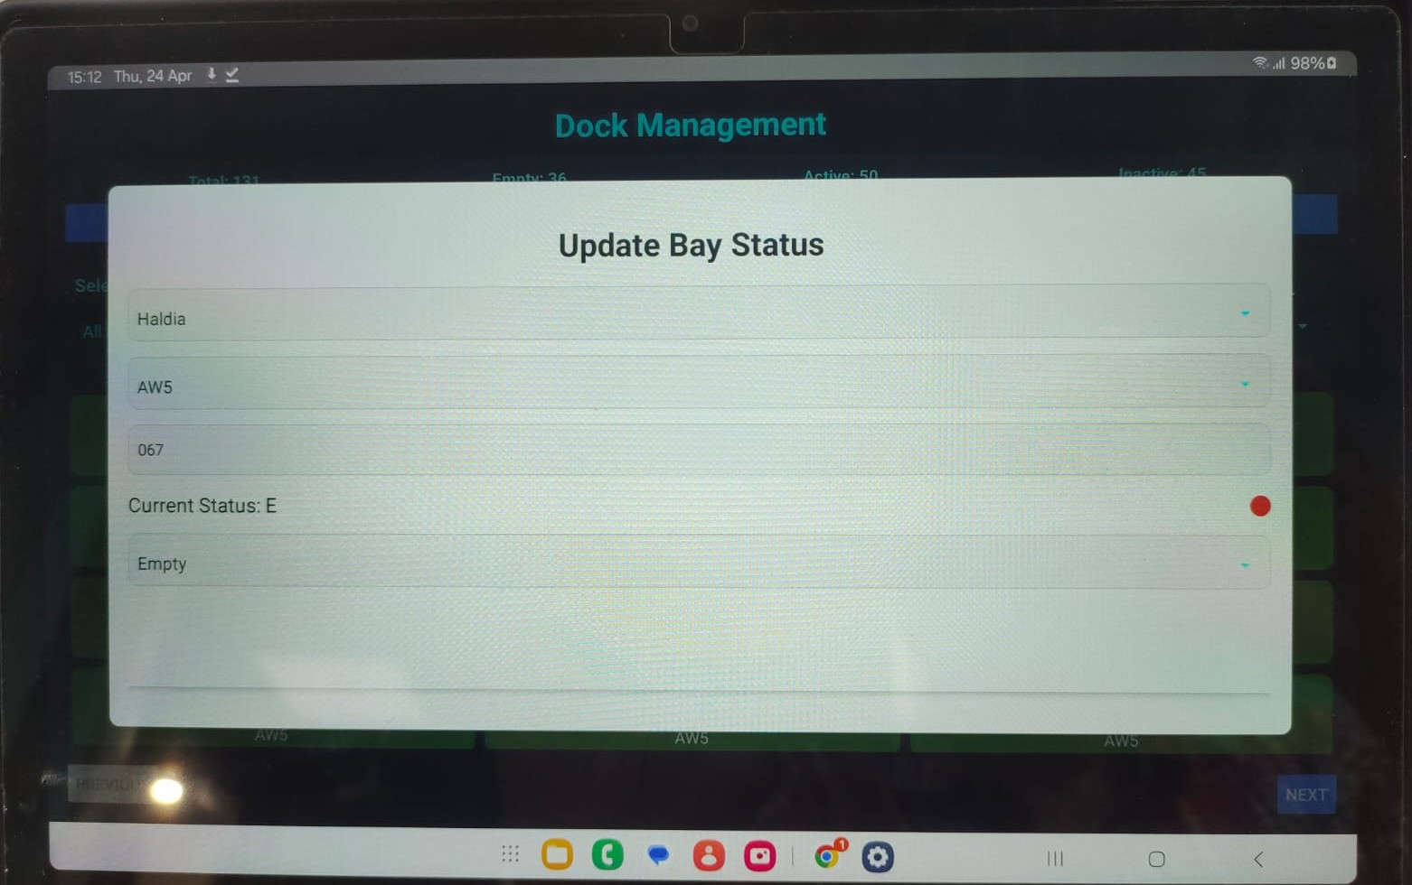

In SAP, the Bay status can be seen from this path –

ZPP_PRO_ORD → Click WM Button → Dock Status

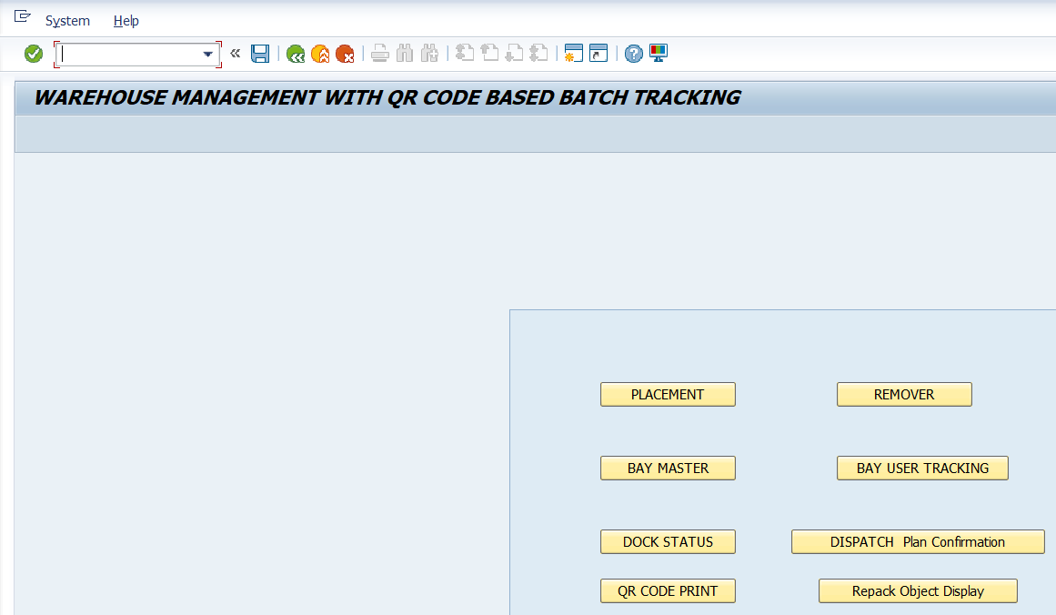

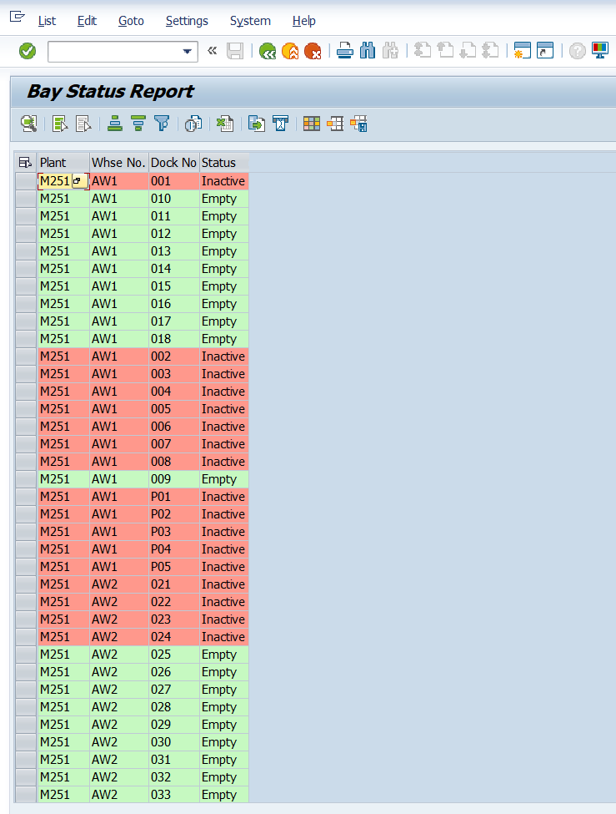

Loading Sequence of Materials maintained in Z table is –

|  |  |  |
| --- | --- | --- |
| **Sequence Serial** | **SKU Type** | **Warehouse** |
| 1 | Edible Oil Tin | AW5 |
| 2 | Edible Oil Tin | AW2 |
| 3 | Rasoi Tin | AW3 |
| 4 | Rasoi Jar | AW3 |
| 5 | Rasoi Jar | AW2 |
| 6 | Rasoi BIB | AW5 |
| 7 | Rasoi BIB | AW2 |
| 8 | Rasoi BIB | AW1 |
| 9 | Soya Chunk PET | AW4 |
| 10 | Soya Chunk Pouch | AW4 |
| 11 | Soya Chunk PET | AW2 |
| 12 | Soya Chunk Pouch | AW2 |
| 13 | Edible Oil Jar 13 / 13.5 Kg | AW2 |
| 14 | Edible Oil Jar 4.5 / 4.25 Kg | AW2 |
| 15 | Edible Oil PET 1.8 Kg | AW2 |
| 16 | Edible Oil PET 850 / 900 gm | AW5 |
| 17 | Edible Oil PET 425 / 450 gm | AW5 |
| 18 | Edible Oil PET 170 / 180 gm | AW5 |
| 19 | Edible Oil PET 850 / 900 gm | AW2 |
| 20 | Edible Oil PET 425 / 450 gm | AW2 |
| 21 | Edible Oil PET 170 / 180 gm | AW2 |
| 22 | Rasoi Pouch 890 gm | AW3 |
| 23 | Rasoi Pouch 445 gm | AW3 |
| 24 | Rasoi Pouch 890 gm | AW2 |
| 25 | Rasoi Pouch 445 gm | AW2 |
| 26 | Edible Oil Pouch 850 / 900 gm | AW5 |
| 27 | Edible Oil Pouch 425 / 450 gm | AW5 |
| 28 | Edible Oil Pouch 850 / 900 gm | AW1 |
| 29 | Edible Oil Pouch 425 / 450 gm | AW1 |
| 30 | Edible Oil Pouch 850 / 900 gm | AW2 |
| 31 | Edible Oil Pouch 425 / 450 gm | AW2 |

Now, the Dispatch process flow is as follows:

Customer requirement placed in DEAL / DMS software → Triggers Inquiry creation in SAP → Sales Order is created against the Inquiry No. in SAP using ZDPLAN by HO DO Team → Truck Indent (TI) No. is also created using ZDPLAN → Indents are raised in TEG s/w automatically based on the Truck Indent → Release Indent → Against this Vehicle Entry Pass No., unique Vehicle Token No. (30 Character) is generated by clicking the “Generate Token” button in TEG s/w → Delivery Order / Outbound Delivery is created in SAP → Token No. is linked with single or multiple DOs → Linking gets reflected in ZWH_TOKENDEL_UPD table in SAP (for Rake, table is ZWH_STOTOKEN_UPD) → **Loading Sequence is executed in background in SAP**\* → Materials in DOs under a VEP Token are sorted according to loading sequence → Assigned Warehouse, Dock, Loading Sequence & Gross Weight (pre-loading) sent to TEG from Android App → Truck does Tare Weighment → Truck comes to assigned Dock → Actual loading starts → Pallets are brough to loading bay → Pallet ID is scanned → Cartons / Tins / Jars are passed under the scanner one by one **→ QR Codes printed on them get scanned with validation check\*\*** → Scan information are stored in ZSD_DISP_ITEM table → When physical loading is complete, process being completed in Android App & generate TO → Loading completion information sent to TEG from Android App → Post-Loading VEP Slip generated with actual loaded batches & respective quantities → Truck goes to Tare Weighment → OBD Update → Auto-PGI → Auto-Invoice → Gate Out

**\*** There are actually 5 steps of sequence checking in SAP –

1. Material Loading Sequence (ZWM_SEQUENCE, ZWM_PRD_SEQUENCE)
2. Batch Sequence (7-days FIFO)
3. Warehouse Sequence (AW5:AW2:AW1 = 3:1:1)
4. Dock Sequence (ZWH_BAY_MASTER)
5. Truck Sequence (ZWH_DISPATCH)

For Modern Trade dispatch, SAP will check the available stock with Available Shelf Life (ASL) ≥ 78%. Within this available stock, system will apply 7-days FIFO logic.

**\*\*** Validation Check in Android App during scanning in Dispatch –

1. Invalid Box Value: Checks if the box QR code is empty or null.
2. Duplication Check: Checks for duplicate boxes.
3. Material Loading Sequence-wise Load: Checks if materials are loaded in sequence.
4. Batch FIFO Maintenance: Checks if batches are loaded in 7 days - FIFO range.
5. Each material-wise 10% Tolerance limit for Loading Quantity
6. DO No.-wise Material Load: Checks if materials are loaded for the correct DO No. & displays a "fully loaded" message.

The Dispatch process in Android App starts with selecting the concerned VEP Token no. from the list of Tokens. (Communication between Android App & TEG is happening through 5 nos. APIs)

**Path:** Dispatch Block → Normal & Modern Trade Dispatch → Token List

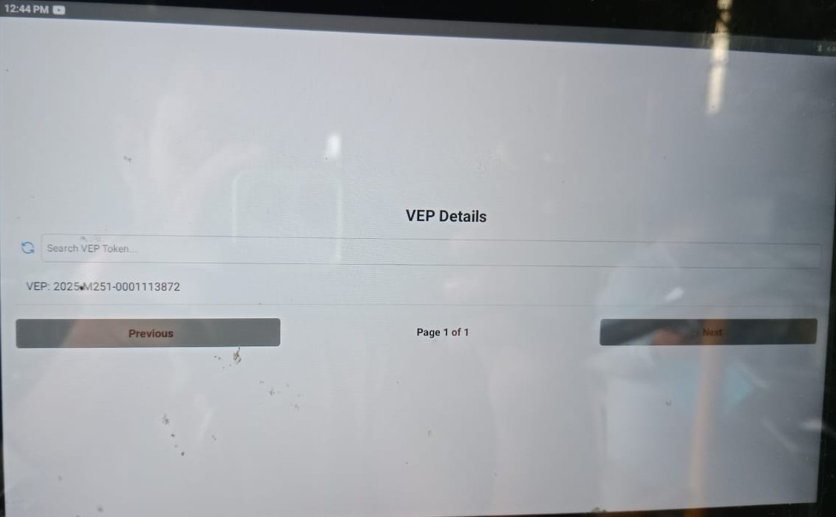

There is search field to search a particular token from the list of tokens displayed.

Clicking desired Token no. leads to display of the linked Delivery Order(s). user need to scroll horizontally (Left to right) to see the full table.

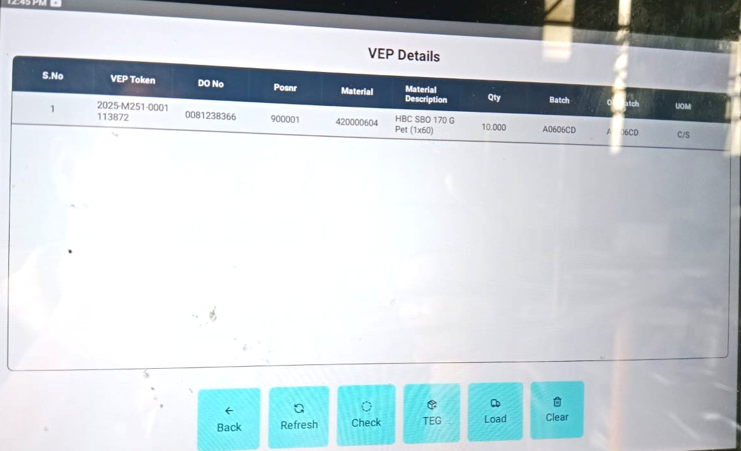

In case of processing Delivery Order containing material from FG01 storage location, the next step is –

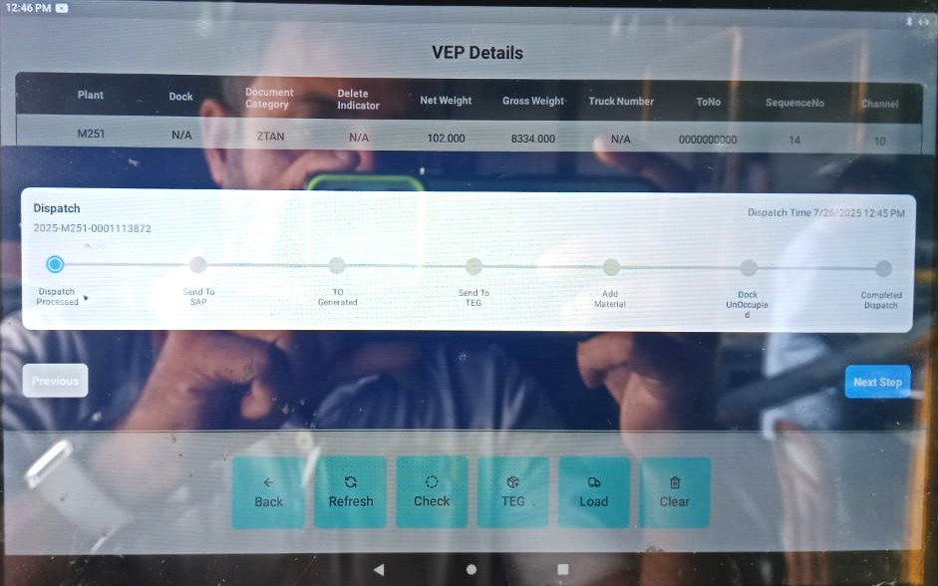

The screen for processing materials from FG01 is like this –

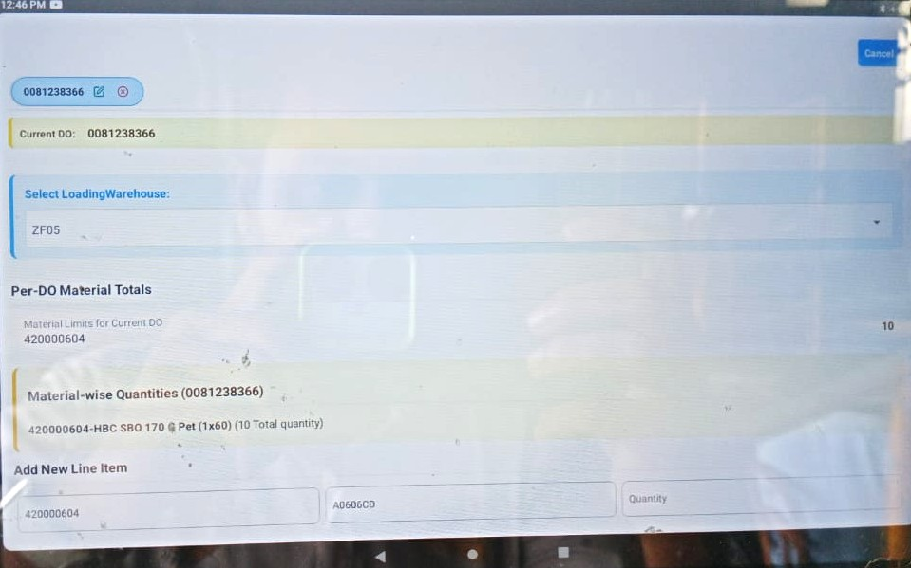

In the “Select Loading Warehouse” drop-down field, user selects the warehouse, the loading is happening from. In most of the cases, possibly this will be Warehouse 5, so its associated SLOC ZF05 is selected.

After the physical loading, the Loading Supervisor gives actual loaded batch & its respective quantity as input in this screen; if new batches have been loaded, then new line item can be created using the “+ Add item” button –

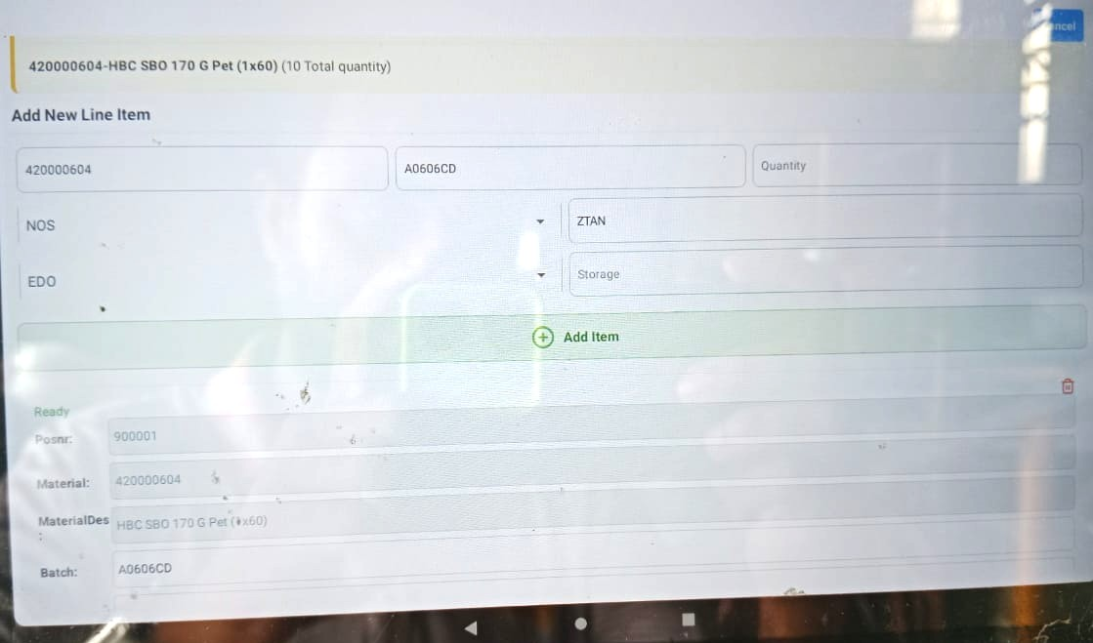

Click “Stock Transfer” & the next screen is like this –

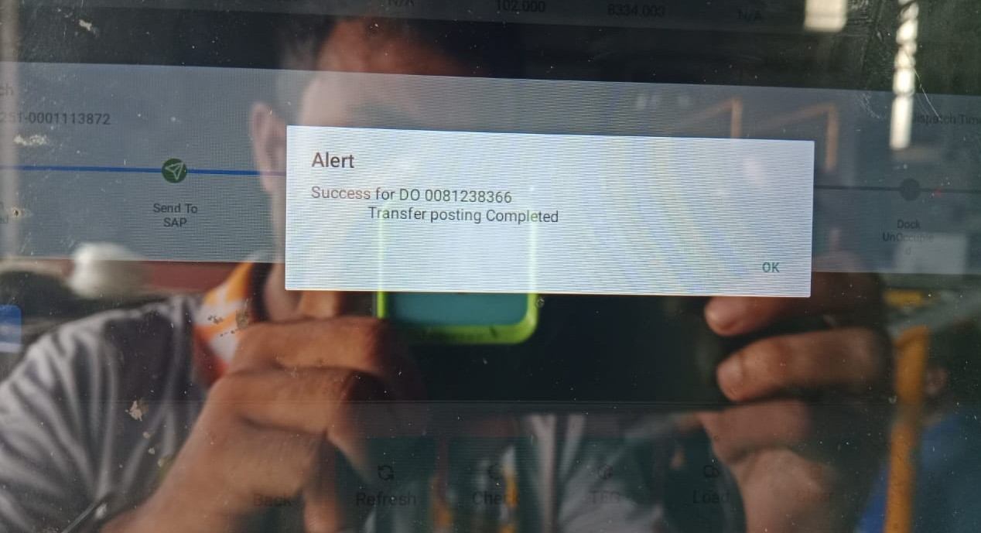

Then,

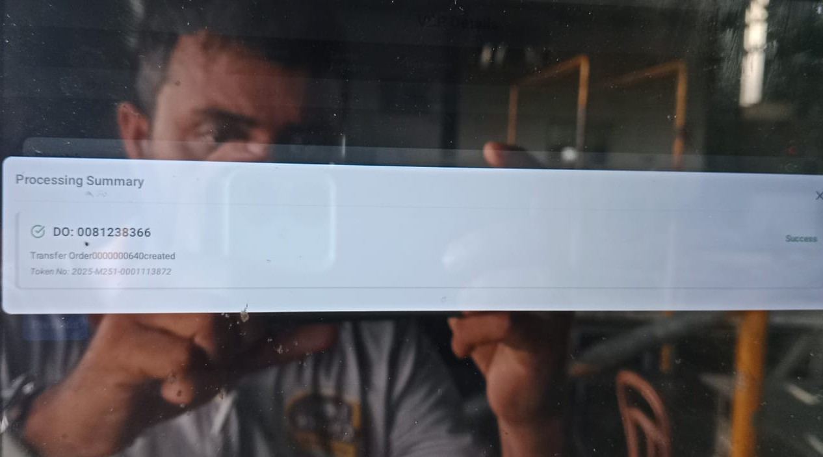

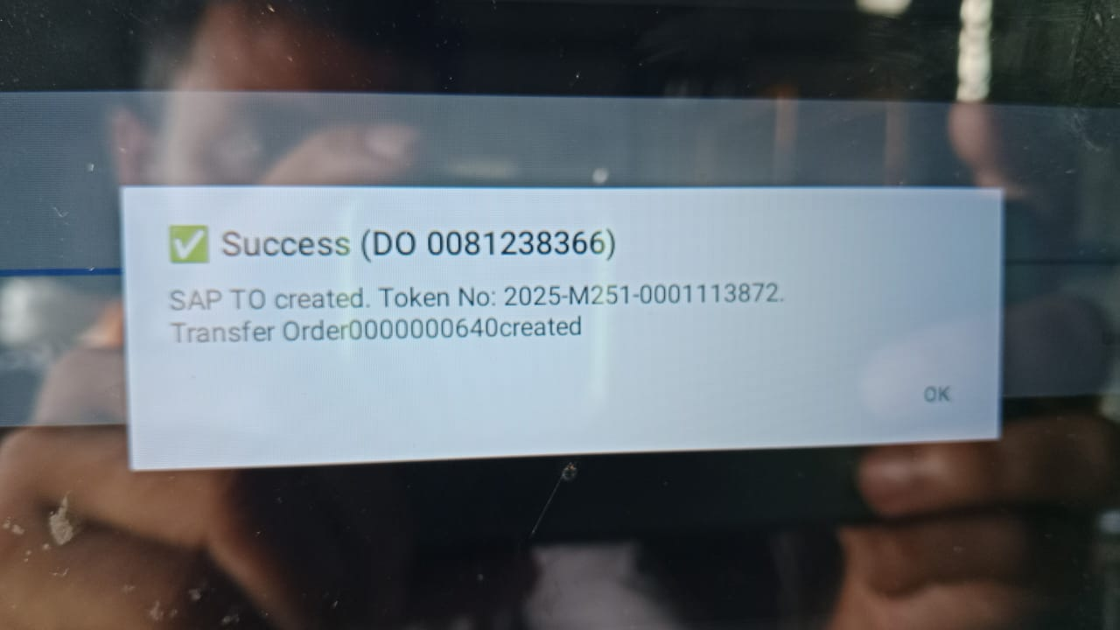

For processing materials from other SLOC apart from FG01, for example, say, from ZF05 (i.e., QR coded materials from Warehouse 5),

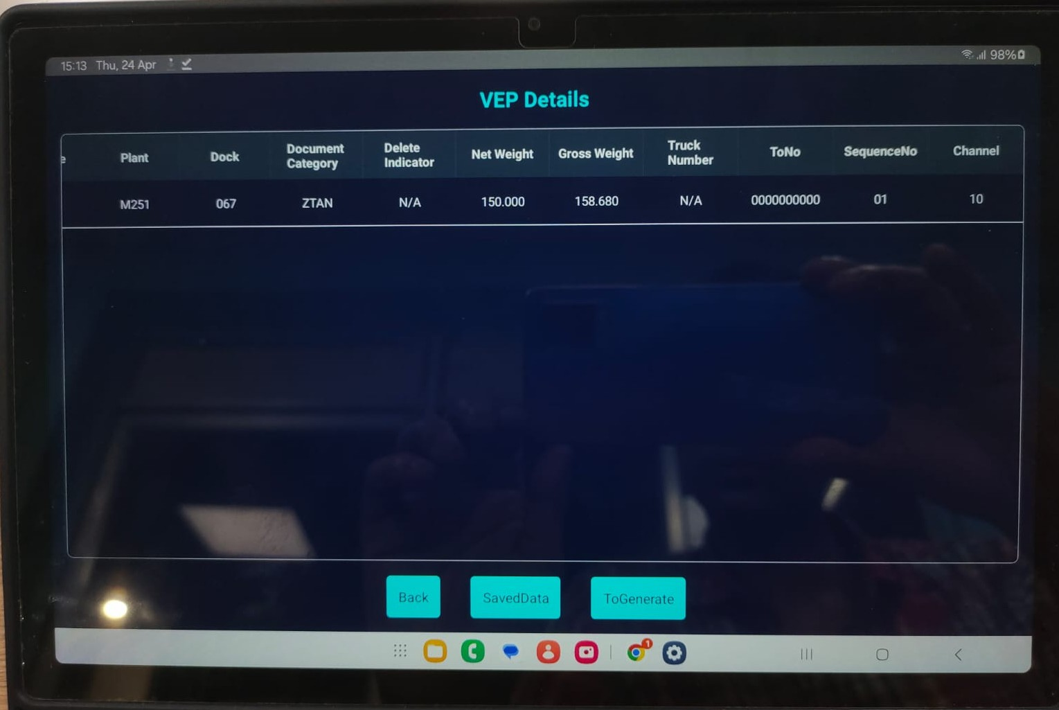

User should click “Saved Data”. Click “Start Scan” in pop-up window. It will lead to the next screen where QR data of the scanned Cartons / Tins / Jars are coming –

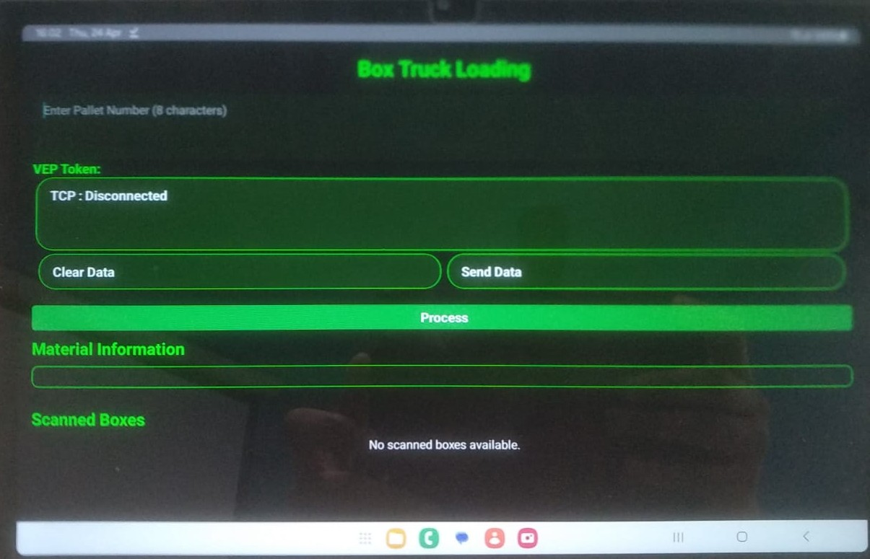

When QR codes are coming to scanner, the display looks like –

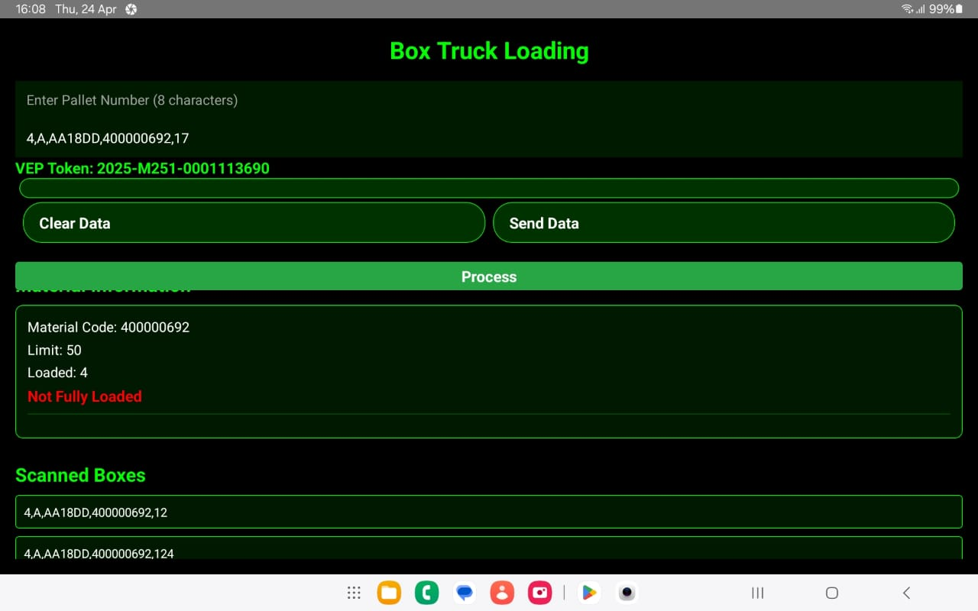

When delivery quantity of a particular material is achieved / met, it shows –

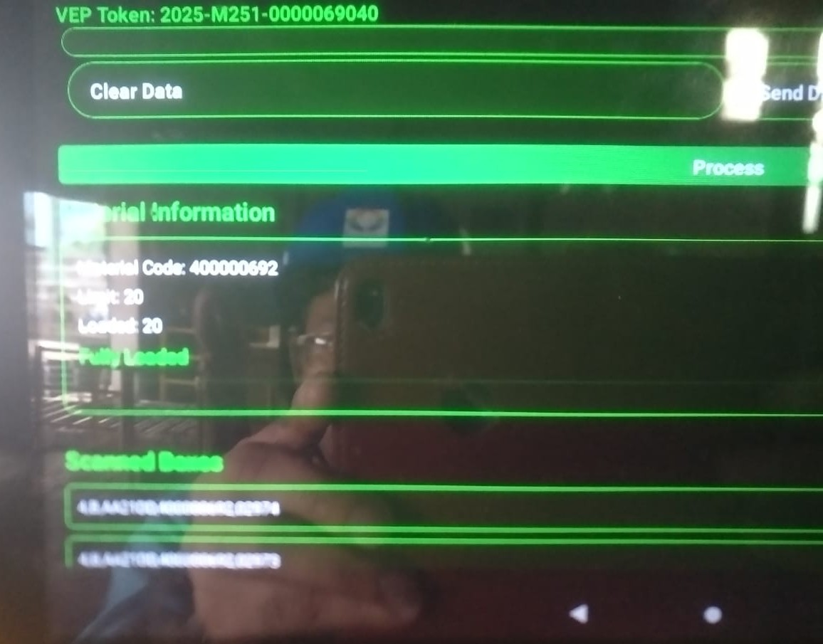

When material loading against DO is complete, click “Process Data”.

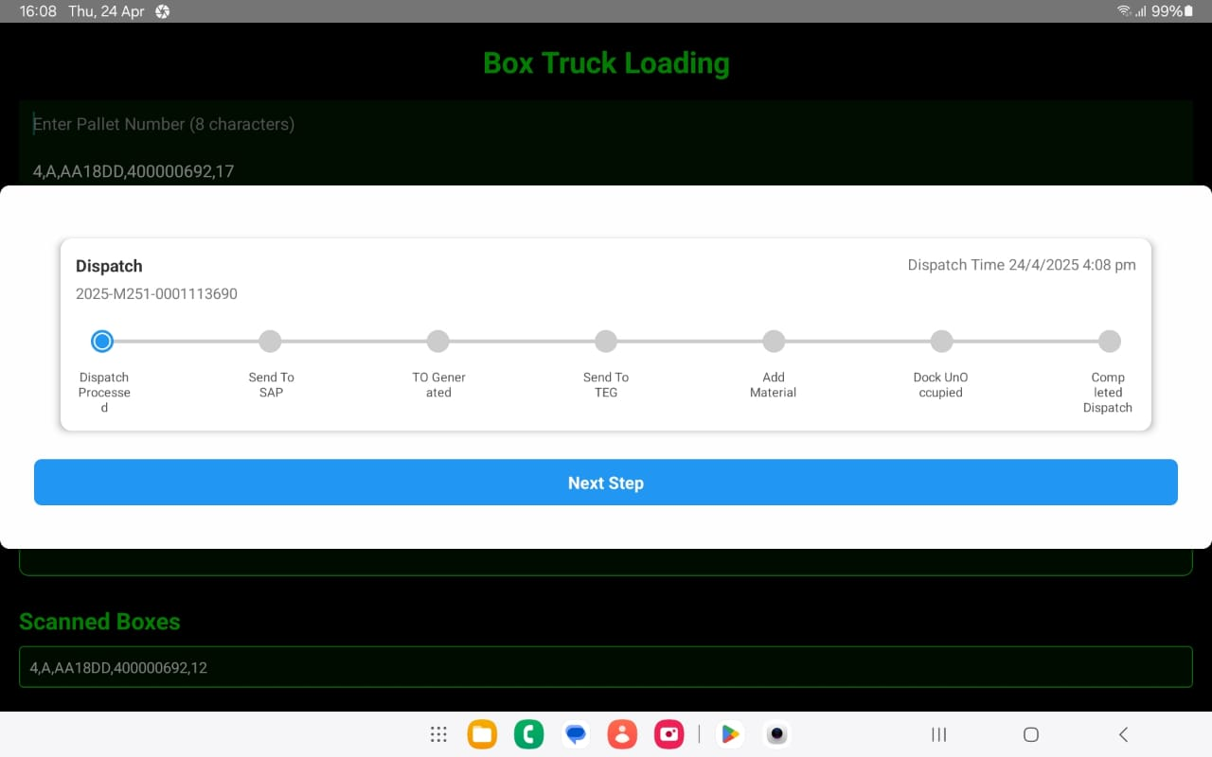

Click Next Step. It will reach “Send to SAP” stage.

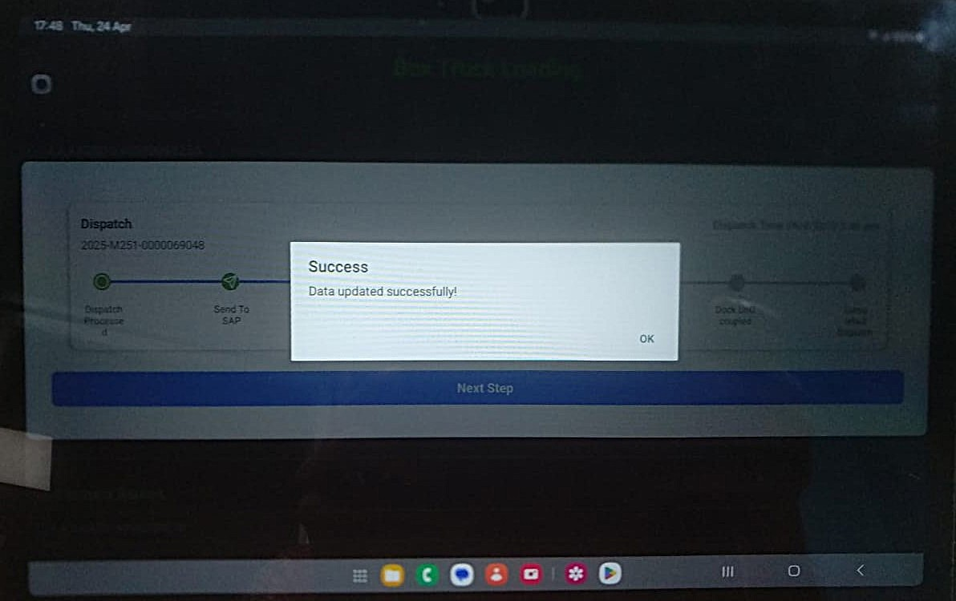

Click Next Step again. It will reach “TO generated” stage.

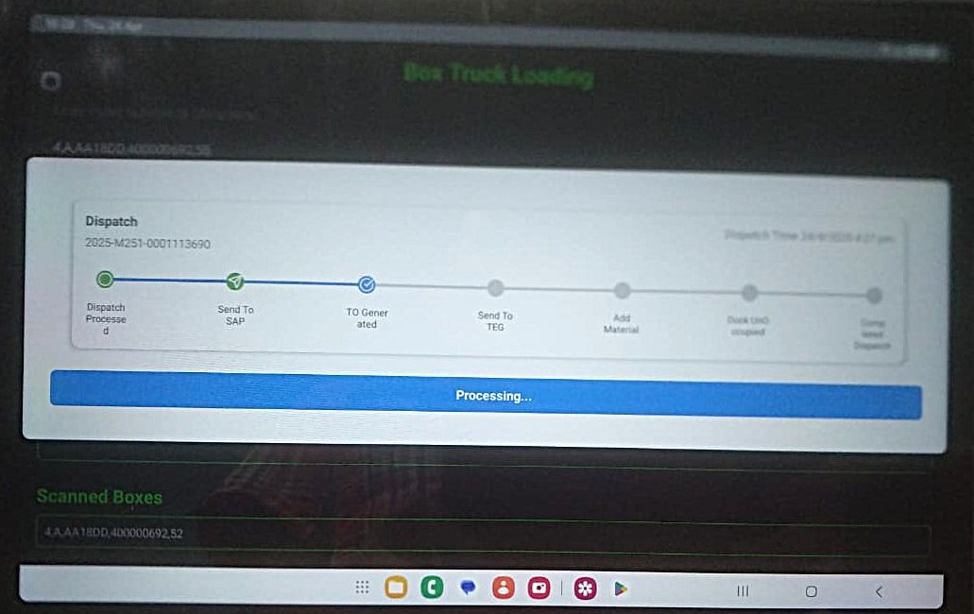

Click Next Step again. It will reach “Send to TEG” stage.

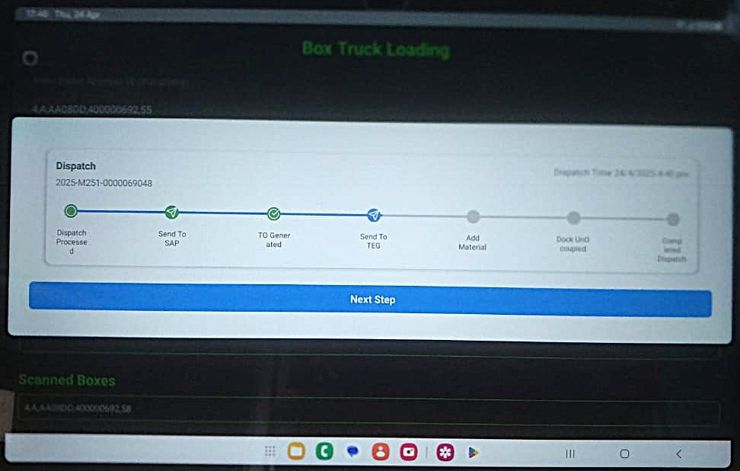

Click Next step again to add additional materials. Click “False” to prompt Additional material screen –

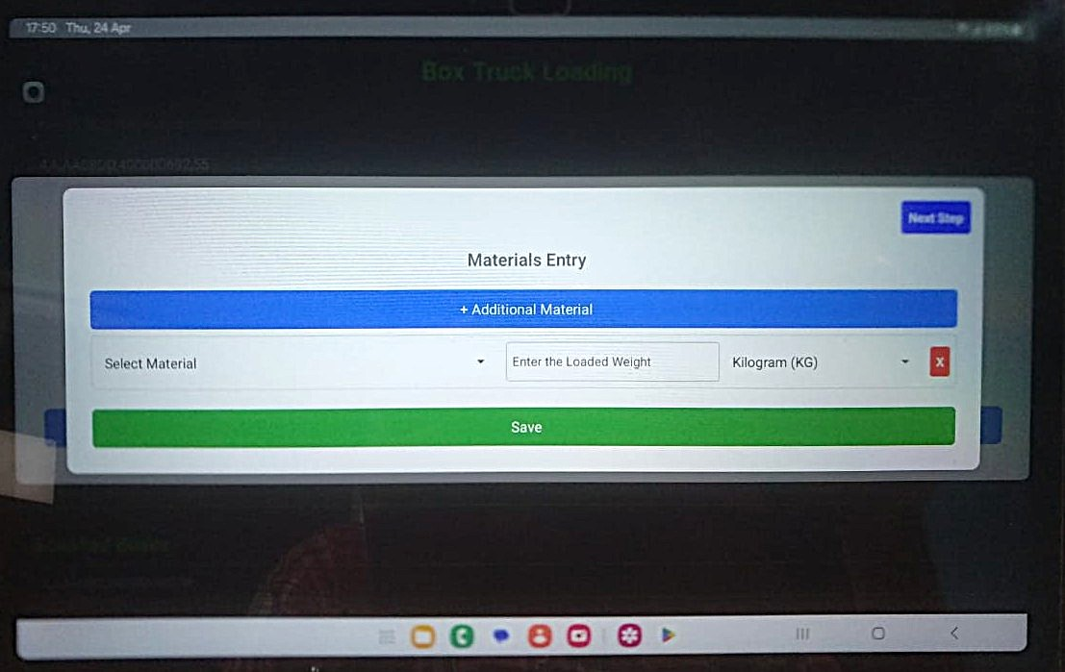

Put desired additional material & its weight –

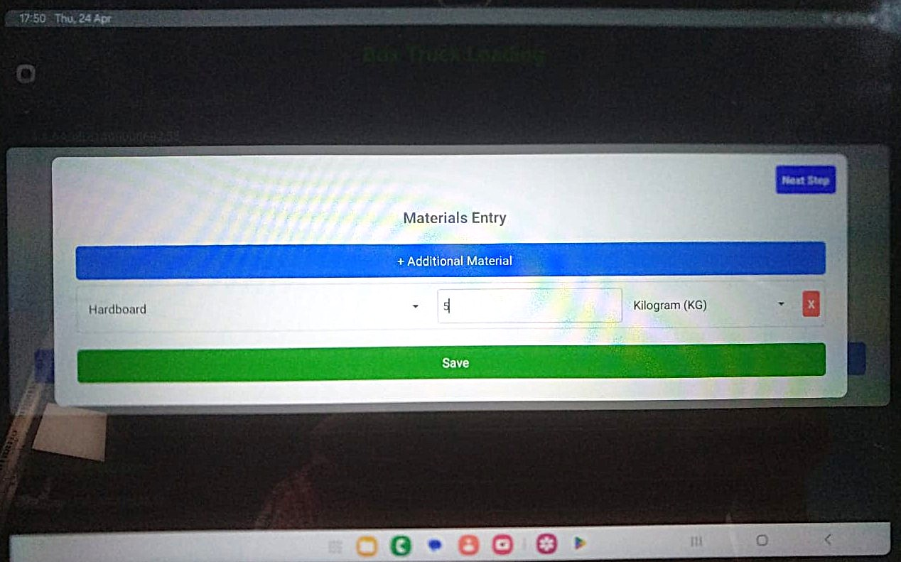

Save. It will show that additional material has been added successfully.

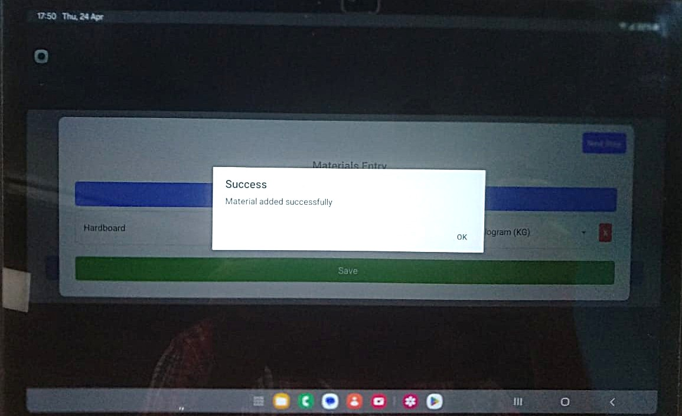

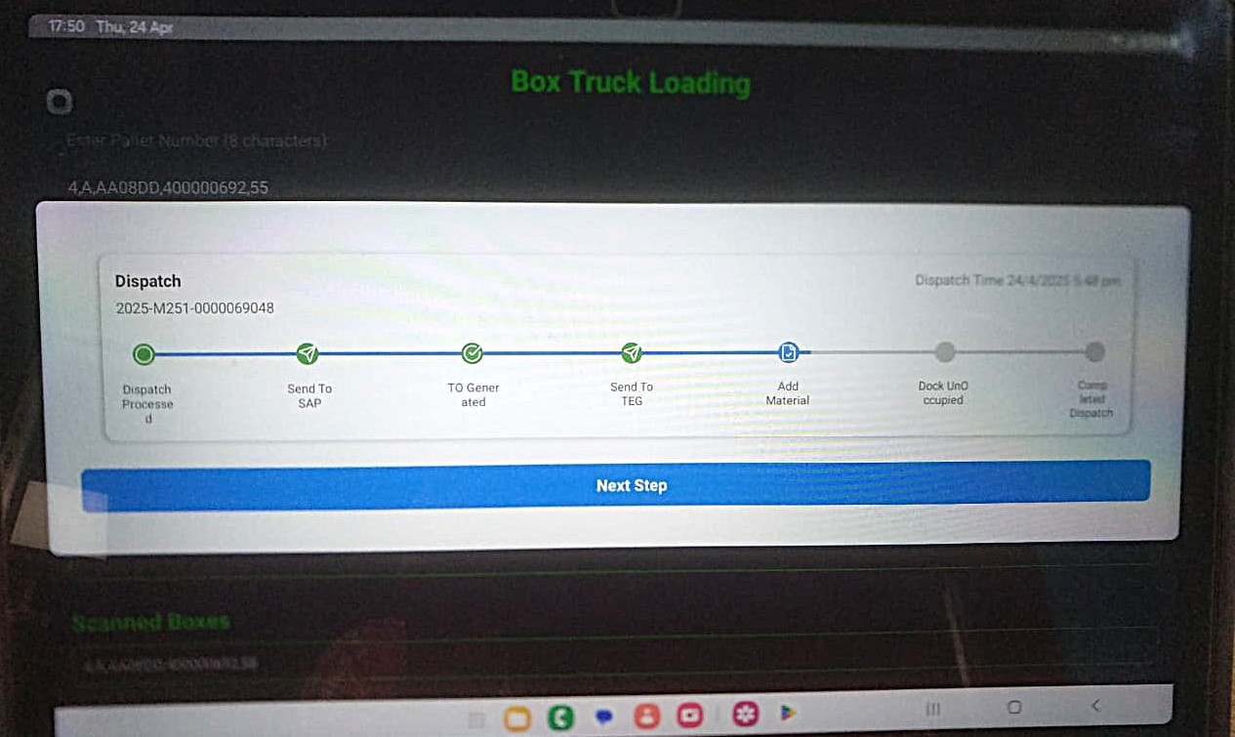

Click Next Step to change Dock Status from Active to Empty.

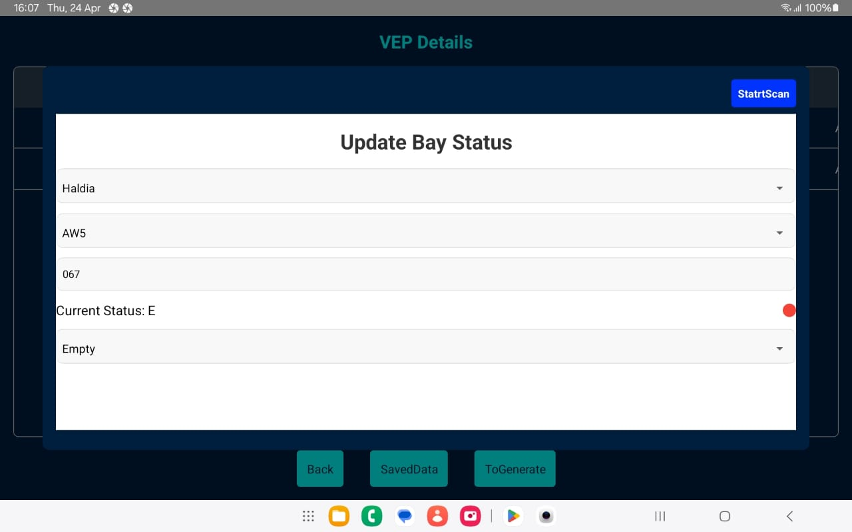

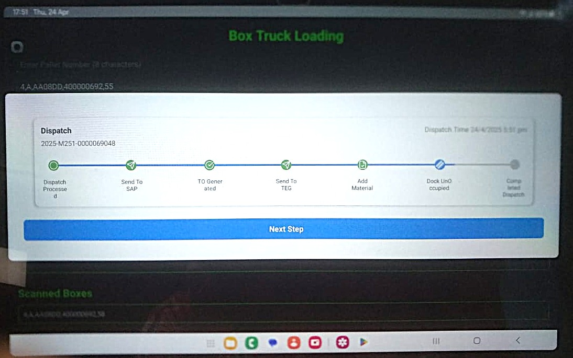

Click Next Step for the last time. It will declare completion of dispatch from Android App.

